OCR GCSE English Literature
(19th century prose unit)
‘Great Expectations’
by Charles Dickens

Easter Homework 2019
Due: Tuesday 30th April

How to use this pack:
- You have a summary of each chapter of the middle section that you must read.
- For some chapters, you must read the chapter as well as the summary (ideally you would read all).
- These chapters are clearly signalled with ‘essential reading’.
- For all of these ‘essential’ chapters, there are questions to answer – these should be completed in the back of your booklet.

Name: _______________________________

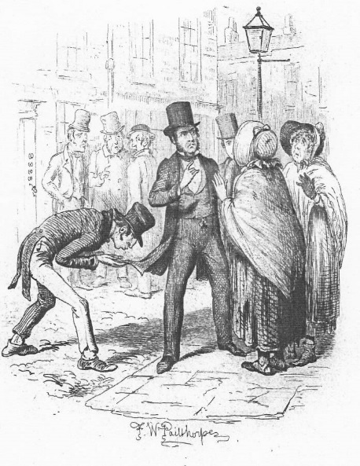
The Second Stage of Pip’s life – Pip learning to be a gentleman in London.
ESSENTIAL READING Chapters 20 and 21 – Pip arrives in London.
It's a five hour carriage ride to London, and when Pip arrives in the big city, he thinks that London is decidedly overrated. Everything is dirty, labyrinthine, and abrasive.
The carriage driver delivers Pip to Jaggers' office. Pip is greeted by a clerk who lets him know that Mr. Jaggers is in court, but that Pip can wait inside.
There are lots of people around, all waiting for Mr. Jaggers.
Pip waits in Mr. Jaggers' office, which is full of such delightful things as Mr. Jaggers' chair, which look likes a coffin, and two casts of gruesome, twitchy faces.
Pip is astonished by the amount of money he is given to live on. Mr Jaggers says that, nonetheless, he is bound to overrun it soon enough.

- What does the coachman’s reaction suggest about Mr Jaggers?
- What does Jaggers’ office reveal about him? Have you encountered this type presentation before?
- How does Jaggers treat the clients around him – how would you sum up his attitude and tone?

ESSENTIAL READING – Chapter 22 - Living with Herbert Pocket.

Pip goes to the place where he is to lodge and discovers that Herbert Pocket, the person he is to live with, is not only related to Miss Havisham but is the boy he fought with in the grounds of Satis House, all those years ago. Both are delighted at this reunion and quickly discover that they get on extremely well. Soon after meeting him, Herbert decides that rather than call him Pip, he will call him Handel.
4. What do we find out about Miss Havisham’s past from the start of this chapter? Try and record all the details of her past to develop a picture of what made her a bitter and lonely spinster.
- What impressions do we get of Herbert Pocket? Use a quotation to help explain your answer.

Chapter 23 - Visiting the Pockets’ house.

Pip settles down in London. He visits Herbert’s large and eccentric family. He goes again to the office of his guardian, Jaggers, where the his clerk, Wemmick, gives him money for furniture and invites him to visit his home at Walworth. He begins lessons in being a gentleman with Matthew Pocket, Herbert’s father and one of Miss Havisham’s relatives. The Pockets’ home is a bustling, chaotic place where the servants run the show. Matthew is absentminded but kind, and his wife is socially ambitious but not well born; the children are being raised by the nurse. Attending with him are two other young men, Startop, who is soft and delicate, and Bentley Drummle, to whom Pip takes an immediate dislike – and who seems to take an equal dislike to him.
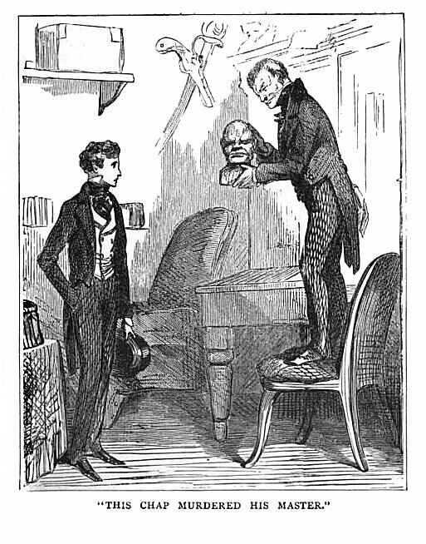
Chapter 24 – Jaggers’s office and the cast iron faces.
Pip returns to Jaggers’s office in order to arrange to share rooms with Herbert. There, Pip befriends the lively Wemmick, who invites him to dinner. They discuss an iron sculpture which turns out to be a cast of the faces of two men just after they had been executed. Wemmick tells Pip of all the jewels and trinkets they receive from criminals about to die, and explains how important he feels it is to have ‘portable property’ – valuables you can leave with quickly. Pip sees Jaggers in the courtroom, where he is a potent and menacing force, frightening even the judge with his thundering speeches.

ESSENTIAL READING – Chapter 25 – Pip visits Wemmick’s house.

Pip continues to get to know his fellow students and the Pockets, attending dinners at both Wemmick’s and Jaggers’s. Wemmick’s house is like something out of a dream, an absurd “castle” in Walworth that he shares with his “Aged Parent.” Pip observes that Wemmick seems to have a new personality.
- How does Pip view Bentley Drummle and Startop? Does it foreshadow/suggest anything about their relationship in the future?
- What does Wemmick reveal about Mr Jaggers and the power he has?
- What is Wemmick like in the ‘castle’? Does it differ to his personality in the office (look specifically at the last line in this chapter)? Why do you think Dickens has done this?

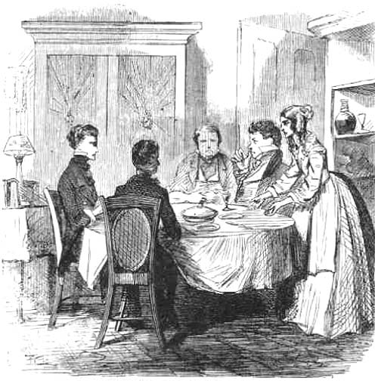
ESSENTIAL READING - Chapter 26 – Pip visits Mr Jaggers’ house.
Soon after his visit to Wemmick’s home, Pip, along with his fellow students Startop and Drummle, is invited for dinner at Jaggers’ home. By contrast, Jaggers’ house is oppressive and dark, shared only with a gloomy housekeeper, Molly. Pip’s fellow students attend the dinner at Jaggers’ with Pip, and Pip and Drummle quarrel over a loan Drummle ungratefully borrowed from Startop. Jaggers warns Pip to stay away from Drummle, though the lawyer claims to like the disagreeable young man himself.
- What is strange about Mr Jaggers’ housekeeper ?
- What is strange about Mr Jaggers’ behaviour around her – does it tell us anything about him? Use a quotation to help explain your answer.
- How does the evening end?
ESSENTIAL READING - Chapter 27 – Joe comes to London.
Joe comes to visit Pip in London. Because Pip worries that Joe will disapprove of his opulent lifestyle and that Drummle will look down on him because of Joe, Joe’s visit is strained and awkward. He tries to tell Pip the news from home: Wopsle, for instance, has become an actor. But Pip acts annoyed with him until Joe mentions that Estella has returned to Satis House and that she wishes to see Pip. Pip suddenly feels more kindly toward Joe, but the blacksmith leaves before Pip can improve his behaviour.
- Why do you think Dickens decided to include Joe’s visit to Pip in London? Decide on the most likely reasons suggested below and explain why.

- It adds some humour to the story.
- It shows how much Pip has changed.
- It makes the reader feel sorry for Pip having such an embarrassing guest.
- It shows that Pip is not the gentleman he thinks he is.
- It reminds the reader of Pip’s background.
- It shows how kind Joe is.
- It shows how right Pip was to leave his home and come to London.

Chapter 28 – Pip goes back home.
Hoping to see Estella and to apologize to Joe, Pip travels home. His coach home is also carrying pair of convicts to a halfway house, one of whom is the mysterious stranger who gave Pip money in the pub. Though this man does not recognize Pip, Pip overhears him explaining that the convict Pip helped that long-ago night in the marshes had asked him to deliver the money to Pip. Pip is so terrified by his memory of that night that he gets off the coach at its first stop within the town limits. When he arrives at his hotel, he reads a notice in a newspaper, from which he learns that Pumblechook is taking credit for his rise in status.
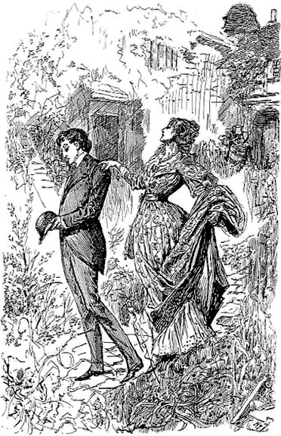
ESSENTIAL READING - Chapter 29 – Pip visits Estella.
When he travels to Satis House the next day, Pip pictures himself as a triumphant knight riding to rescue the Lady Estella from an evil castle. He encounters Orlick, now Miss Havisham’s porter, at the gate – something Pip is not best pleased about. When he sees Estella, he is stunned: she is now grown up and more beautiful than ever. She acknowledges that Pip is much changed and no longer as coarse as once he was. Pip walks with Estella in the garden, but she treats him with indifference, and he becomes upset. Pip realizes that she reminds him of someone, but he can’t place the resemblance. Back inside, he discovers Jaggers there and feels oppressed by the lawyer’s heavy presence. Miss Havisham is pleased that Pip is in awe of Estella’s beauty and urges him to ‘love her’. Pip still thinks he is destined for Estella; this seems to be confirmed when he learns that Estella is to come to London where he will be her escort. He decides to stay at the Blue Boar again instead of going to stay with Joe.
- How does Orlick behave around Pip?
- Using at least 3 quotations, analyse how the grown up Estella is presented. You could look at the way she behaves, the way she is described, what she says or what Pip (and others) say about her in the narration.
- Near the end of this chapter, Miss Havisham repeats the phrase “love her, love her, love her!” – what effect does the repetition of this phrase have? How does Pip interpret it?

ESSENTIAL READING Chapter 30 –Pip feels let down.
The next day, Pip tells Jaggers about Orlick’s past, and Jaggers fires the man from Miss Havisham’s employment. Pip is mocked by the Mr Trabb’s (the tailor) apprentice as he walks down the street so he has him sacked as well. He returns in low spirits to London, where Herbert tries to cheer him up. Herbert cautions him against assuming he is destined for Estella and suggests she would not make him happy. Pip insists he cannot simply stop loving her. Herbert tells Pip that he is in love with and secretly engaged to Clara, a girl without money or prospects, and that he is too poor himself for the marriage at the moment.
16. Why does Pip remember the scene with Trabb’s boy so vividly, many years later?
17. Choose a quotation from page 212 that explores Pip’s insecurity about his identity.
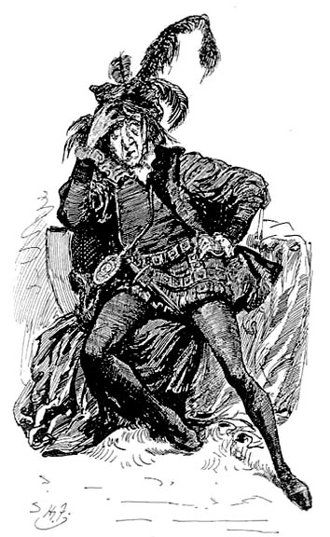
18. Pick one contrast between Herbert and Pip that emerges in their conversation at the end of this chapter.
Chapter 31 – Mr Wopsle as Hamlet.
Pip and Herbert go to the theatre, where Wopsle plays a ridiculous Hamlet. Pip takes the hapless actor out to dinner following the play, but his mood remains sour.

ESSENTIAL READING - Chapter 32 – Wemmick amongst the convicts.
Pip receives a note from Estella, ordering him to meet her at a London coach station. He arrives very early and encounters Wemmick, who takes him on a brief tour of the miserable grounds of Newgate Prison. Pip feels uncomfortable in the dismal surroundings, but Wemmick is oddly at home, even introducing Pip to a man who has been sentenced to death by hanging. It reminds him of his association in the past with the convicts.
- How is Newgate Prison described?
- “It struck me that Wemmick walked among the prisoners, much as a gardener might walk among his plants” – Using this and one other quotation, explain Wemmick’s relationship with the prisoners and guards on duty there.

