GCSE Geography Revision Guidance
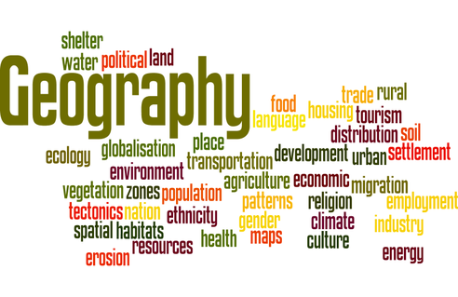

Exam Board: Edexcel - Specification A

There are three exam papers –
*Paper 1 - The Physical environment: 1 hour 30 minutes
A. The changing landscapes of the UK: you must answer question 1 (a short question specifically about the UK landscape);
-you must answer the optional questions: 2.Coastal landscapes & processes; AND 3.River landscapes & processes; and NOT 4.Glaciation.

B. Weather hazards & Climate change: answer all questions.
C. Ecosystems, biodiversity & management: answer all questions.
*Paper 2 - The Human environment: 1 hour 30 minutes
A. Changing Cities: answer all questions (Includes case studies of a major UK city (Bristol) and a major developing world city (Sao Paulo).
B. Global development: answer all questions (Includes a case study of a developing country (Ghana).
C. Resource Management: you must answer question 1 (a short question about global and UK resources);
-you must answer the optional question: 6B: Water resource management; and NOT 6A: Energy resource management.

*Paper 3 - Geographical investigation, Field work & UK challenges: 1 hour 30 mins
Section A: Geographical investigations – physical environments. There are two questions in this section but you will only answer ONE of them – the one called ‘Rivers’ NOT the one called ‘Coasts’. It will test some of the skills you gained during the Rivers field work exercise.
Section B: Geographical investigations – human environments. There are two questions in this section but you will only answer ONE of them – the one called ‘Central/Inner Urban Area’ NOT the one called ‘Rural Settlements’. It will test some of the skills you gained during the Urban field work exercise.
Section C: UK challenges -
● The exam includes multiple-choice questions, short open, open response, calculations, 8-mark and 12-mark extended writing questions.

Revision Guides
-A workbook & Guide booklets: can be obtained from the Geog.dept. Cost: £ 5.00
-BBC Bitesize: on-line (free).

