History at WES – Revision Guidance
The examination board for history at WES is AQA. The AQA website contains guidance about how the exams will work and is worth a look. Our course must cover a thousand years of history and must include a British element. There will be two exam papers. With this in mind, we have chosen the following topics for you to study:

Paper 1 – 1 hour 45 minutes, 50% of grade | Paper 2 - 1 hour 45 minutes, 50% of grade
America, 1920–1973: Opportunity and inequality  Part one: American people and the 'Boom'  Part two: Bust – Americans' experiences of the Depression and New Deal  Part three: Post-war America | Britain: Migration, empires and the people: c790 to the present day  Part one: Conquered and conquerors  Part two: Looking west  Part three: Expansion and empire  Part four: Britain in the 20th century
Conflict and tension, 1894–1918  Part one: The causes of the First World War  Part two: The First World War: stalemate  Part three: Ending the war | Norman England, c1066–c1100  Part one: The Normans: conquest and control  Part two: Life under the Normans  Part three: The Norman Church and monasticism  Part four: The historic environment of Norman England (2018: Durham Cathedral)
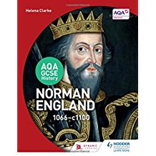
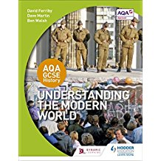
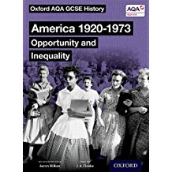
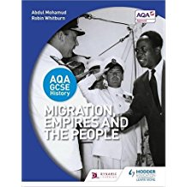

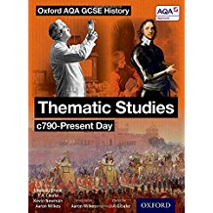
These are the main textbooks available for our course. As yet there is no revision book for Migration or WW1.
Follow this link for the textbook for America and WW1
For BBC Bitesize revision resources follow these links:
The Normans
Migration

History at WES – Exam question types:
The two exam papers for GCSE History have a range of different questions covering one or more of the following aspects: knowledge; understanding; analysis; evaluation; sources; interpretations.
Students will be expected to answer every single question on the topics they have studied:
Paper 1: USA
- How does Interpretation B differ from Interpretation A…? [4 marks]
- Why might the authors of Interpretations A and B have a different interpretation…? [4 marks]
- Which interpretation do you find more convincing…? [8 marks]
- Describe… [4 marks]
- [Explain] in what ways __________ were affected by __________? [8 marks]
- Which of the following was the more important reason…? [12 marks]
- Factor A
- Factor B

Paper 1: WW1
- Study Source A. Source A __________ [suggests a certain view] How do you know? [4 marks]
- How useful are Sources B and C to a historian…? [12 marks]
- Write an account of… [8 marks]
- ‘__________.’ How far do you agree with this statement? [16 marks + 4 SPaG]

Paper 2: Migration, empires and the people
- How useful is Source A to a historian…? [8 marks]
- Explain the significance of… [8 marks]
- Compare __________ with __________. In what ways were they similar/different? [8 marks]
- Has __________ been the main factor? Explain your answer with reference to __________ and other factors. [16 marks + 4 SPaG]

Paper 2: Norman England, c1066–c1100
- How convincing is Interpretation A about…? [8 marks]
- Explain what was important about… [8 marks]
- Write an account of… [8 marks]
- ‘__________.’ How far does a study of Durham Cathedral support this statement? [16 marks]

We have produced or acquired a range of resources to support students through their GCSE History, so please don’t hesitate to contact us if you need any more guidance.
Mr Edwards (edwards@williamellis.camden.sch.uk)
Ms Conway (conway@williamellis.camden.sch.uk)
Mr Germanos (germanos@williamellis.camden.sch.uk)
Good luck!

