Q1. (a) Figure 1 shows the horizontal forces acting on a moving bicycle and cyclist.
Figure 1
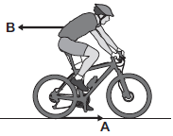
(i) What causes force A?
Draw a ring around the correct answer.
friction gravity weight
(1)
(ii) What causes force B?
______________________________________________________________
(1)
(iii) In this question you will be assessed on using good English, organising information clearly and using specialist terms where appropriate.
Figure 2 shows how the velocity of the cyclist changes during the first part of a journey along a straight and level road. During this part of the journey the force applied by the cyclist to the bicycle pedals is constant.
Figure 2
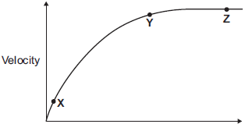
Time
Describe how and explain, in terms of the forces A and B, why the velocity of the cyclist changes:
• between the points X and Y
• and between the points Y and Z, marked on the graph in Figure 2.
______________________________________________________________
______________________________________________________________
______________________________________________________________
______________________________________________________________
______________________________________________________________
______________________________________________________________
______________________________________________________________
______________________________________________________________
______________________________________________________________
______________________________________________________________
______________________________________________________________
______________________________________________________________
Extra space ____________________________________________________
______________________________________________________________
______________________________________________________________
______________________________________________________________
______________________________________________________________
______________________________________________________________
______________________________________________________________
______________________________________________________________
______________________________________________________________
______________________________________________________________
______________________________________________________________
______________________________________________________________
(6)
(b) (i) The cyclist used the brakes to slow down and stop the bicycle.
A constant braking force of 140 N stopped the bicycle in a distance of 24 m.
Calculate the work done by the braking force to stop the bicycle. Give the unit.
______________________________________________________________
______________________________________________________________
______________________________________________________________
Work done = ______________________________
(3)
(ii) Complete the following sentences.
When the brakes are used, the bicycle slows down. The kinetic energy of the
bicycle ______________________________ .
At the same time, the ______________________________ of the brakes
increases.
(2)
(Total 13 marks)
Q2. The diagram shows a boat pulling a water skier.
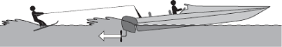
(a) The arrow represents the force on the water produced by the engine propeller.
This force causes the boat to move.
Explain why.
___________________________________________________________________
___________________________________________________________________
___________________________________________________________________
___________________________________________________________________
(2)
(b) The boat accelerates at a constant rate in a straight line. This causes the velocity of the water skier to increase from 4.0 m/s to 16.0 m/s in 8.0 seconds.
(i) Calculate the acceleration of the water skier and give the unit.
______________________________________________________________
______________________________________________________________
______________________________________________________________
Acceleration = _________________________
(3)
(ii) The water skier has a mass of 68 kg.
Calculate the resultant force acting on the water skier while accelerating.
______________________________________________________________
______________________________________________________________
______________________________________________________________
Resultant force = _________________________ N
(2)
(iii) Draw a ring around the correct answer to complete the sentence.
The force from the boat pulling the water skier forwards

 | less than
will be | the same as | the answer to part (b)(ii).
 | greater than
Give the reason for your answer.
______________________________________________________________
______________________________________________________________
(2)
(Total 9 marks)
Q3. A baby monitor has a sensor unit that transmits an image of the baby and the noises the baby makes to a monitor unit.
The monitor unit then displays an image of the baby and emits the noises the baby makes.
(a) Compare the properties of the waves that transmit images and noises from the monitor unit.
___________________________________________________________________
___________________________________________________________________
___________________________________________________________________
___________________________________________________________________
___________________________________________________________________
___________________________________________________________________
___________________________________________________________________
___________________________________________________________________
___________________________________________________________________
___________________________________________________________________
(4)
(b) The sensor unit can detect infrared and visible light.
Suggest one advantage of being able to detect infrared.
___________________________________________________________________
___________________________________________________________________
(1)
(c) Write down the equation that links frequency, wave speed and wavelength.
Equation ___________________________________________________________
(1)

(d) The signals for the monitor unit are transmitted as electromagnetic waves with a wavelength of 0.125 m.
Wave speed of electromagnetic waves = 3 × 10⁸ m / s
Calculate the frequency of the signal.
___________________________________________________________________
___________________________________________________________________
___________________________________________________________________
___________________________________________________________________
Frequency = __________________ Hz
(3)
(Total 9 marks)
Q4. (a) The picture shows a speed gun being used to measure how fast a tennis player hits the ball.
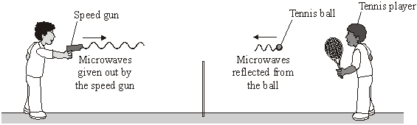
Some of the microwaves from the speed gun are absorbed by the ball and some are reflected by the ball.
(i) Complete the following sentence by choosing one of the phrases from the box.

longer than the same as shorter than
The wavelength of the microwaves reflected from the ball are
__________________________________ the wavelength of the microwaves
from the speed gun.
(1)
(ii) Complete the following sentence by drawing a ring around the correct line in the box.

 | decrease slightly
When the ball absorbs microwaves, its temperature will | not change
 | increase slightly
(1)
(b) The microwaves reflected from the ball have a higher frequency than the microwaves from the speed gun.
The graph shows how the difference between the two frequencies depends on the speed of the ball.
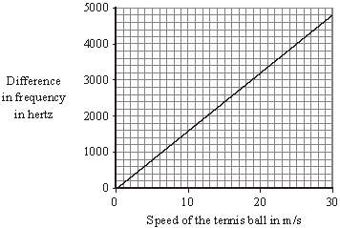
(i) Describe the pattern that links the difference between the two frequencies and the speed of the ball.
______________________________________________________________
______________________________________________________________
(1)
(ii) The speed gun measures the difference between the two frequencies as 3200 Hz.
Use the graph to find the speed of the tennis ball.
Show clearly on the graph how you obtain your answer.
Speed of the tennis ball = _______________ m/s
(2)
(iii) Which one of the following gives the reason why the data has been shown as a line graph and not as a bar chart?
Put a tick () in the box next to your choice.

Frequency and speed are both categoric variables.
Frequency and speed are both continuous variables.
Speed is a continuous variable and frequency is a categoric variable.
(1)
(Total 6 marks)

Q5. (a) Complete the description of the device shown below by drawing a ring around the correct line in each box.
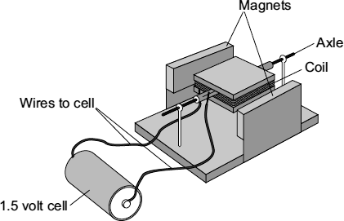

 |  | an electric motor.
(i) | The device is being used as | a generator.
 |  | a transformer.
(1)
(ii) The coil needs a flick to get started. Then one side of the coil is pushed by the

cell
coil | and the other side is pulled, so that the coil spins.
force
(1)
(b) Suggest two changes to the device, each one of which would make the coil spin faster.
1. _________________________________________________________________
___________________________________________________________________
2. _________________________________________________________________
___________________________________________________________________
(2)
(c) Suggest two changes to the device, each one of which would make the coil spin in the opposite direction.
1. _________________________________________________________________
___________________________________________________________________
2. _________________________________________________________________
___________________________________________________________________
(2) (Total 6 marks)
Q6. An electric current is a flow of electrical charge through a circuit.
(a) Complete the sentence.
Use a word from the box.

atoms | electrons | ions | molecules
Metals are good conductors of electricity because electrical charge is transferred
by delocalised __________________________(1)
(b) Draw one line from each symbol to the name of the component.
Standard symbol Name of component
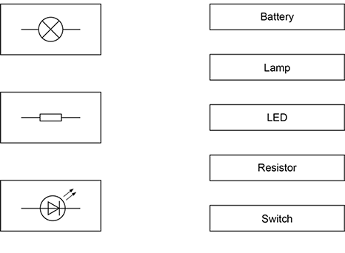 (3)
(c) The table below shows information about some electrical appliances.

Electrical appliance | Power in watts
Hairdryer | 1500
Kettle | 2500
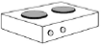  Electric hob | 3000
Television | 360
A student plugs all four of the appliances into one multi-way socket.
The mains electricity is 230 V.
The highest safe current in the socket is 30 A.
Explain why it is not safe to use all four appliances at the same time.
In your answer you should:
• calculate the total power needed
• use the equation
current = power ÷ potential difference
to calculate the total current needed.
___________________________________________________________________
___________________________________________________________________
___________________________________________________________________
___________________________________________________________________
___________________________________________________________________
___________________________________________________________________
___________________________________________________________________
___________________________________________________________________
(4)
(d) The figure below shows how electrical power is transferred from power stations to consumers using the National Grid.
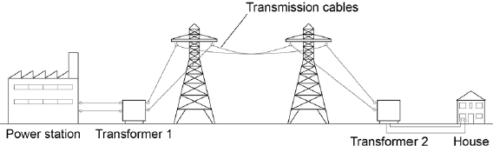
Transformer 1 is a step-up transformer.
Explain why step-up transformers are used in the National Grid.
___________________________________________________________________
___________________________________________________________________
___________________________________________________________________
___________________________________________________________________
___________________________________________________________________
___________________________________________________________________
(3)
(e) What is the purpose of Transformer 2?
___________________________________________________________________
___________________________________________________________________
(1)
(f) In a power station 900 MJ of thermal energy were released by burning natural gas.
Write down the equation that links efficiency, useful input energy transfer and useful output energy transfer.
___________________________________________________________________
(1)
(g) In a power station 900 MJ of thermal energy were released by burning natural gas.
Only 405 MJ was generated.
Calculate the efficiency of this energy transfer.
___________________________________________________________________
___________________________________________________________________
___________________________________________________________________
Efficiency = _________________
(2)
(Total 15 marks)

