Q1.
Feeding relationships can be shown using food chains.
The figure below shows a food chain for organisms in a habitat.
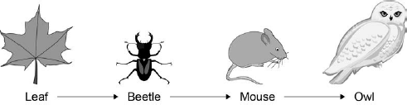
(a) What is the producer in the food chain?
Tick one box.

Beetle | 
Leaf
Mouse
Owl
(1)
(b) Name the primary consumer in the food chain.
___________________________________________________________________
(1)
(c) What is the group of leaves, beetles, mice and owls in a habitat called?
Tick one box.

Community
Ecosystem
Population
Species
(1)
(d) What are two abiotic factors that can affect the food chain?
Tick two boxes.

Availability of food
Light intensity
New diseases
New predators
Wind direction
(2)
(Total 5 marks)
Q2.
The picture shows a basilisk lizard. Some of the adaptations of the lizard are labelled.
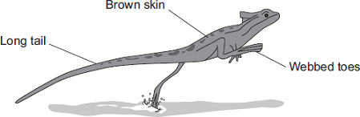
Basilisk lizards are often found resting on branches of trees that grow next to water.
Basilisk lizards can run across the surface of the water.
(a) Draw one line from each adaptation of the lizard to the advantage of the adaptation.
Adaptation Advantage

For camouflage on branches of trees
Toes on the back
feet are webbed
Helps the lizard to
balance when running
Long tail
Warning colours to
deter predators
Brown skin
Increases surface
area in contact with
the water
(3)
(b) Suggest one advantage to the basilisk lizard of being able to run across the surface of the water.
___________________________________________________________________
___________________________________________________________________
(1)
(c) Animals, such as lizards, compete with each other.
Give two factors that animals compete for.
Tick () two boxes.

Oxygen | 
Food
Territory
Light
(2)
(Total 6 marks)
Q3.
Organisms compete with each other.
(a) Figure 1 shows two types of seaweed which live in similar seashore habitats.
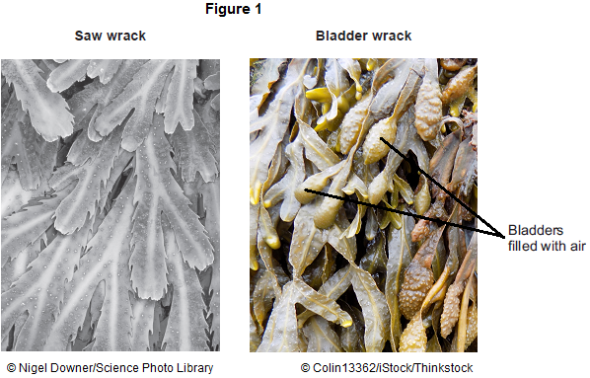
Most of the time the two seaweeds are covered with water.
Bladder wrack has bladders filled with air.
Bladder wrack grows more quickly than saw wrack.
Suggest an explanation why.
___________________________________________________________________
___________________________________________________________________
___________________________________________________________________
___________________________________________________________________
___________________________________________________________________
___________________________________________________________________
___________________________________________________________________
(3)
(b) Figure 2 shows an angler fish.
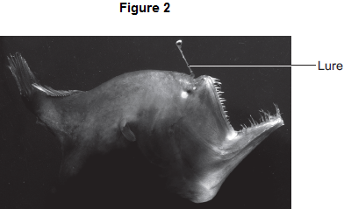
© Dante Fenolio/Science Photo Library
Angler fish live at depths of over 1000 m.
In clear water, sunlight does not usually reach more than 100 m deep.
Many angler fish have a transparent ‘lure’ containing a high concentration of bioluminescent bacteria.
Bioluminescent bacteria produce light.
Suggest an advantage to the angler fish of having a lure containing bioluminescent bacteria.
___________________________________________________________________
___________________________________________________________________
___________________________________________________________________
___________________________________________________________________
___________________________________________________________________
(2)
(Total 5 marks)
Q4.
Desert plants are adapted for survival in a dry climate.
(a) Joshua trees live in deserts.
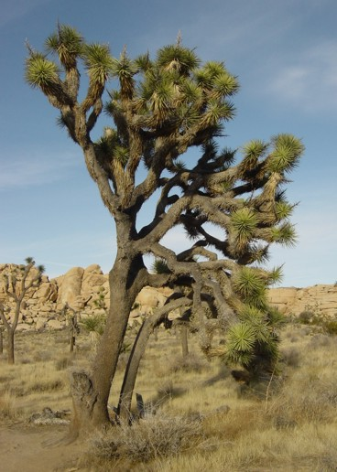
By nyenyec [CC BY-SA 3.0], via Wikimedia Commons
Joshua trees have two different types of root:
• a system of shallow roots spread out over a large area
• roots about 1 m in diameter, shaped like bulbs, deep in the soil.
Explain the advantage to the Joshua tree of having:
(i) shallow roots spread out over a large area
______________________________________________________________
______________________________________________________________
______________________________________________________________
______________________________________________________________
(2)
(ii) large, bulb-like roots deep in the soil.
______________________________________________________________
______________________________________________________________
(1)
(b) Creosote bushes also live in deserts.
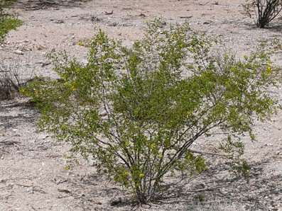
By Sue in az (Own work) [Public domain], via Wikimedia Commons
The leaves of creosote bushes:
• are covered with a layer of wax
• fold together during the day.
Explain how the leaves of the Creosote bush help it to survive in deserts.
___________________________________________________________________
___________________________________________________________________
___________________________________________________________________
___________________________________________________________________
___________________________________________________________________
___________________________________________________________________
(3)
(Total 6 marks)
Q5.
Animals in a habitat compete with each other.
(a) Give two factors for which animals may compete.
1. _________________________________________________________________
2. _________________________________________________________________
(2)
(b) The photographs show a mule deer and a white-tailed deer.
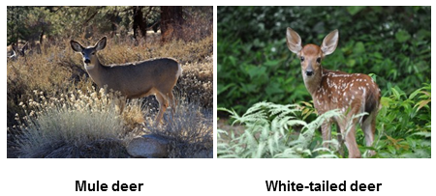
Mule deer by Dcrjsr (Own work) [CC-BY-3.0], via Wikimedia Commons. White-tailed deer by
Clay Heaton (Own work) [CC-BY-SA-3.0], via Wikimedia Commons
Mule deer and white-tailed deer live together in the same national park in the USA.
The graph shows changes in the populations of the two deer species between 1983 and 1999.
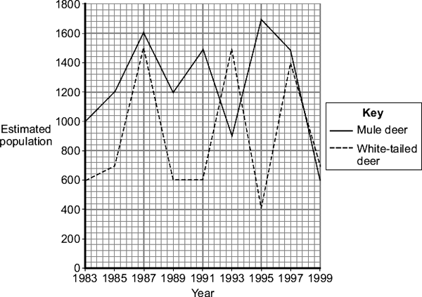
(i) Describe the changes in the population of white-tailed deer between 1991 and 1995.
______________________________________________________________
______________________________________________________________
______________________________________________________________
______________________________________________________________
(2)
(ii) Use information from the graph to suggest an explanation for changes in the population of white-tailed deer between 1991 and 1995.
______________________________________________________________
______________________________________________________________
______________________________________________________________
______________________________________________________________
(2)
(Total 6 marks)
Q6.
In this question you will be assessed on using good English, organising information clearly and using specialist terms where appropriate.
The diagram shows part of the carbon cycle.
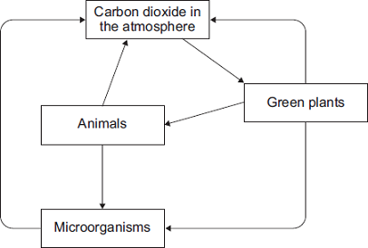
Describe how living things are involved in the constant cycling of carbon.
_______________________________________________________________________
_______________________________________________________________________
_______________________________________________________________________
_______________________________________________________________________
_______________________________________________________________________
_______________________________________________________________________
_______________________________________________________________________
_______________________________________________________________________
_______________________________________________________________________
_______________________________________________________________________
_______________________________________________________________________
_______________________________________________________________________
_______________________________________________________________________
_______________________________________________________________________
_______________________________________________________________________
_______________________________________________________________________
_______________________________________________________________________
(Total 6 marks)
Q7.
The diagram shows part of the carbon cycle.
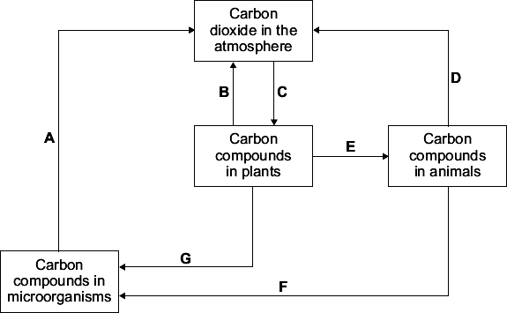
(a) Letter A represents respiration.
Which two other letters represent respiration?

 | and
(1)
(b) Other than carbon dioxide name two carbon compounds found in plants.
1. _________________________________________________________________
2. _________________________________________________________________
(2)
(c) Gardeners use compost heaps to decay dead plants. Decayed compost is then spread onto the soil in a garden.
Explain why gardeners spread decayed compost onto the soil.
___________________________________________________________________
___________________________________________________________________
___________________________________________________________________
___________________________________________________________________
(2)
(Total 5 marks)
Mark schemes
Q1.
(a) Leaf
1
(b) Beetle
1
(c) Community
1
(d) Light intensity
1
Wind direction
1
[5]
Q2.
(a)
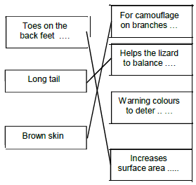
one mark for each line
do not award mark for an adaptation if lines are drawn from it to more than one advantage
3
(b) escape (predators)
accept faster than swimming
allow chase prey
allow it stops them from drowning
1
(c) food
1
territory
1
deduct one mark for each tick in excess of two
[6]
Q3.
(a) gets more light (near surface)
allow warmer (near surface)
allow bladders contain (more) carbon dioxide
1
(so) photosynthesises more
1
(because) bladders aid floating (when tide is in)
or
(so) more biomass / glucose / starch produced
ref to ‘more’ needed only once, eg gets more light for photosynthesis gains two marks
if ‘more’ not given do not award mark on the first occasion
1
(b) lets angler fish see / attract its prey / mates or see predators as it is dark (at 1000m)
or
lets angler fish see / attract prey to get food
or
lets angler fish see / attract mates to reproduce
or
lets angler fish see predators to avoid being eaten
must be in a correct pair to gain two marks
2
[5]
Q4.
(a) (i) increased water uptake
ignore nutrients / food
allow quicker water uptake
allow collects water over larger area
1
(after) rain
accept ideas in terms of more successful competitor
1
(ii) water storage or stability or safety from predators
ignore absorption of water from soil
1
(b) reduces water loss / evaporation
accept reduces transpiration
allow stops water loss
1
wax protects plant or reflects heat or keeps plant cool or unpalatable
ignore reflects light
1
folding reduces surface area or folding reduces warming
accept enclosed stomata or less exposure of stomata or increased humidity or less water concentration gradient
allow prevents burning
ignore less likely to be damaged
1
[6]
Q5.
(a) any two from:
• food / feeding
ignore water
• mates / mating
• territory / space / land / shelter / nesting sites
ignore homes / place to live / habitat / resources
• status (within group)
2
(b) (i) rises to 1480 to 1500
or rises by 880 to 900
or rises until 1993
ignore incorrect figures if 1993 given
1
falls to 400 to 440 or falls by 1040 to 1100
if neither mark gained then allow 1 mark for rise followed by fall or fell by 160 to 200
1
(ii) rises because: -
less competition from mule deer
or mule deer population falling
or fewer mule deer
ignore reference to food / breeding
ignore reference to predation / disease
1
falls because: -
more competition from mule deer
or mule deer population rising
or more mule deer
ignore more / less suited to environment
if neither mark gained then correct reference to competition gains 1 mark
1
[6]
Q6.
Marks awarded for this answer will be determined by the Quality of Written Communication (QWC) as well as the standard of the scientific response. Examiners should also refer to the information in the Marking guidance.
0 marks
No relevant content.
Level 1 (1-2 marks)
For at least one process either the organism that carries it out or the carbon compound used or the carbon compound produced is described or for at least one organism either the carbon compound it uses or the carbon compound it produces is described or at least one process is named
Level 2 (3-4 marks)
For some processes (at least one of which is named) either the organisms involved or the carbon compounds used or the carbon compounds produced are described
Level 3 (5-6 marks)
For at least one named process an organism and either the carbon compound used for the process or the carbon compound produced by the process are described and for other processes (at least one of which is named) either the organism or the carbon compounds used or the carbon compounds produced are described (as in Level 2)
Examples of Biology points made in the response:
• (green) plants photosynthesise
• photosynthesis takes in carbon dioxide
• (green) plants use carbon to make carbohydrate / protein / fat / organic compounds / named (e.g. enzymes / cellulose)
• animals eat (green) plants (and other animals)
• (green) plants respire
• animals respire
• respiration releases carbon dioxide
• (green) plants and animals die
• microorganisms decay / decompose / rot / break down / feed on dead organisms
• microorganisms respire
[6]
Q7.
(a) B and D
both required in any order
1
(b) any two from:
do not accept compounds restricted to animals
• carbohydrate / named example
allow 2 marks for 2 named examples
do not allow a general name and a named example for 2 marks (eg award 1 mark only for carbohydrate and starch)
• protein / enzyme
allow 2 marks for 2 named examples
• amino acid
• hormone / named plant hormone
• lipid / fat / oil / wax
• chlorophyll
• DNA
• vitamin(s)
2
(c) contains minerals / salts / ions / nutrients / named
ignore ‘food’
do not allow vitamins / glucose / energy etc
1
(needed by plants) for health / better growth
for / help plant growth is insufficient
ignore moisture retention / soil structure
ignore more plants
allow examples linked to mineral eg contains magnesium to make chlorophyll for 2 marks
1
[5]

