Q1. The diagram below shows a person using a device called a jetpack. Water is forced downwards from the jetpack and produces an upward force on the person.
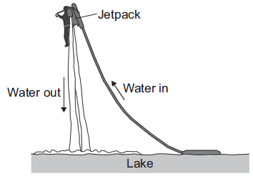
(a) State the condition necessary for the person to be able to remain stationary in mid-air.
___________________________________________________________________
___________________________________________________________________
(1)
(b) The person weighs 700 N and the jetpack weighs 140 N.
(i) Calculate the combined mass of the person and the jetpack.
Gravitational field strength = 10 N/kg
______________________________________________________________
______________________________________________________________
______________________________________________________________
Combined mass = ___________ kg
(2)
(ii) Increasing the upward force to 1850 N causes the person to accelerate upwards.
Calculate the acceleration of the person and the jetpack. Give the unit.
______________________________________________________________
______________________________________________________________
______________________________________________________________
______________________________________________________________
Acceleration = ___________ Unit ___________
(3)
(Total 6 marks)

Q2. The diagram shows a fork-lift truck with a load of 2.4 kN. The clockwise moment caused by this load is 2880 Nm.
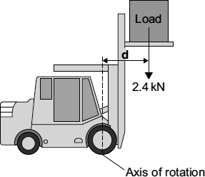
(a) Use the equation in the box to calculate the distance d.

moment = force × | perpendicular distance from the line of  action of the force to the axis of rotation
Show clearly how you work out the answer and give the unit.
___________________________________________________________________
___________________________________________________________________
___________________________________________________________________
Distance d = ____________________________
(3)
(b) This warning notice is in the driver’s cab.
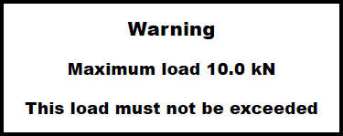
Explain in terms of moments why the maximum load must not be exceeded.
___________________________________________________________________
___________________________________________________________________
___________________________________________________________________
___________________________________________________________________
___________________________________________________________________
________________________________________________________(2)(Total 5 marks)
Q3. A train travels from town A to town B.
Figure 1 shows the route taken by the train.
Figure 1 has been drawn to scale.
Figure 1
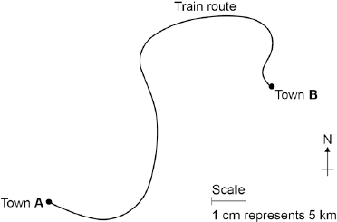
(a) The distance the train travels between A and B is not the same as the displacement of the train.
What is the difference between distance and displacement?
___________________________________________________________________
___________________________________________________________________
___________________________________________________________________
(1)
(b) Use Figure 1 to determine the displacement of the train in travelling from A to B.
Show how you obtain your answer.
___________________________________________________________________
___________________________________________________________________
Displacement = ___________________ km
Direction = _________________________
(2)
(c) There are places on the journey where the train accelerates without changing speed.
Explain how this can happen.
___________________________________________________________________
___________________________________________________________________
___________________________________________________________________
___________________________________________________________________
(2)
(d) Figure 2 shows how the velocity of the train changes with time as the train travels along a straight section of the journey.
Figure 2
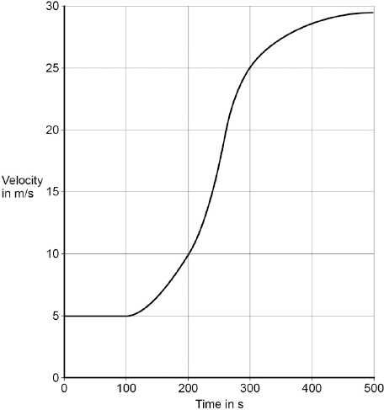
Estimate the distance travelled by the train along the section of the journey shown in Figure 2.
To gain full marks you must show how you worked out your answer.
___________________________________________________________________
___________________________________________________________________
___________________________________________________________________
___________________________________________________________________
Distance = _________________________ m
(3)
(Total 8 marks)

Q4.Figure 1 shows how atmospheric pressure varies with altitude.
Figure 1
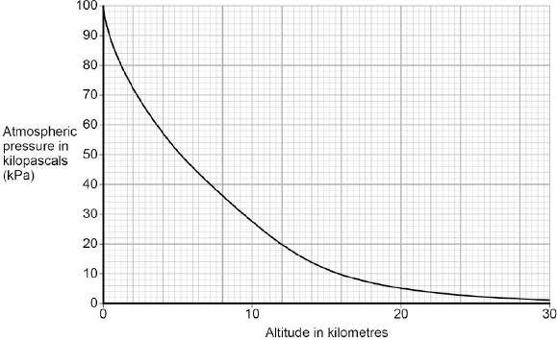
(a) Explain why atmospheric pressure decreases with increasing altitude.
___________________________________________________________________
___________________________________________________________________
___________________________________________________________________
___________________________________________________________________
___________________________________________________________________
___________________________________________________________________
(3)
(b) When flying, the pressure inside the cabin of an aircraft is kept at 70 kPa.
The aircraft window has an area of 810 cm².
Use data from Figure 1 to calculate the resultant force acting on an aircraft window when the aircraft is flying at an altitude of 12 km.
Give your answer to two significant figures
___________________________________________________________________
___________________________________________________________________
___________________________________________________________________
___________________________________________________________________
___________________________________________________________________
Resultant force = ___________________ N (5)
(c) Figure 2 shows the cross-section of one type of aircraft window.
Figure 2
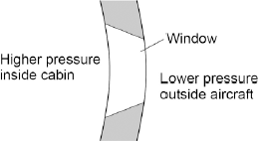
Explain why the window has been designed to have this shape.
___________________________________________________________________
___________________________________________________________________
___________________________________________________________________
(2)
(Total 10 marks)
Q5. Waves may be either longitudinal or transverse.
(a) Describe the difference between a longitudinal and a transverse wave.
___________________________________________________________________
___________________________________________________________________
___________________________________________________________________
___________________________________________________________________
(2)
(b) Describe one piece of evidence that shows when a sound wave travels through the air it is the wave and not the air itself that travels.
___________________________________________________________________
___________________________________________________________________
___________________________________________________________________
(1)
(c) The figure below shows the parts of a moving-coil loudspeaker.
A coil of wire is positioned in the gap between the north and south poles of the cylindrical magnet.
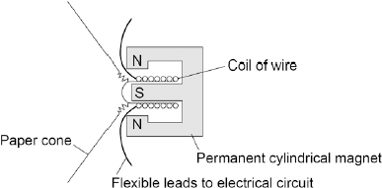
Explain how the loudspeaker converts current in an electrical circuit to a sound wave.
___________________________________________________________________
___________________________________________________________________
___________________________________________________________________
___________________________________________________________________
___________________________________________________________________
___________________________________________________________________
___________________________________________________________________
___________________________________________________________________
___________________________________________________________________
___________________________________________________________________
(6)
(Total 9 marks)
Q6. The diagram shows apparatus set up by a student.
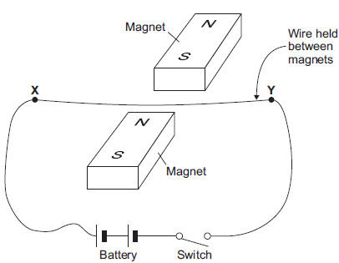
Closing the switch creates a force that acts on the wire XY.
(a) (i) Explain why a force acts on the wire XY when the switch is closed.
______________________________________________________________
______________________________________________________________
______________________________________________________________
______________________________________________________________
______________________________________________________________
(3)
(ii) The force causes the wire XY to move.
Draw an arrow on the diagram above to show the direction in which the wire XY will move.
(1)
(iii) State the effect that this experiment demonstrates.
______________________________________________________________
(1)
(b) The student replaced the battery with a low frequency alternating current (a.c.) power supply.
The student closed the switch.
(i) Describe the movement of the wire.
______________________________________________________________
(1)
(ii) Give a reason for your answer to part (i).
______________________________________________________________
______________________________________________________________
______________________________________________________________
(1)
(Total 7 marks)
Q7. Galaxies emit all types of electromagnetic wave.
(a) (i) Which type of electromagnetic wave has the shortest wavelength?
______________________________________________________________
(1)
(ii) State one difference between an ultraviolet wave and a visible light wave.
______________________________________________________________
______________________________________________________________
(1)
(b) Electromagnetic waves travel through space at a speed of 3.0 x 10⁸ m/s.
The radio waves emitted from a distant galaxy have a wavelength of 25 metres.
Calculate the frequency of the radio waves emitted from the galaxy and give the unit.
___________________________________________________________________
___________________________________________________________________
___________________________________________________________________
Frequency = ___________________________________
(3)
(c) Scientists use a radio telescope to measure the wavelength of the radio waves emitted from the galaxy in part (b) as the waves reach the Earth. The scientists measure the wavelength as 25.2 metres. The effect causing this observed increase in wavelength is called red-shift.
(i) The waves emitted from most galaxies show red-shift.
What does red-shift tell scientists about the direction most galaxies are moving?
______________________________________________________________
______________________________________________________________
(1)
(ii) The size of the red-shift is not the same for all galaxies.
What information can scientists find out about a galaxy when they measure the size of the red-shift the galaxy produces?
______________________________________________________________
______________________________________________________________
______________________________________________________________
______________________________________________________________
(2)
(iii) What does the observation of red-shift suggest is happening to the Universe?
______________________________________________________________
______________________________________________________________
(1)
(Total 9 marks)

Q8. (a) As part of its life cycle, a star changes from being a protostar to a main sequence star.
Explain the difference between a protostar and a main sequence star.
___________________________________________________________________
___________________________________________________________________
___________________________________________________________________
___________________________________________________________________
(2)
(b) The early Universe contained only atoms of hydrogen. The Universe now contains atoms of over one hundred different elements.
Explain how the different elements now contained in the Universe were formed.
___________________________________________________________________
___________________________________________________________________
___________________________________________________________________
___________________________________________________________________
___________________________________________________________________
___________________________________________________________________
(3)
(Total 5 marks)

