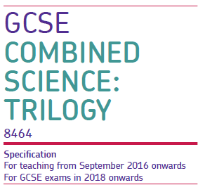
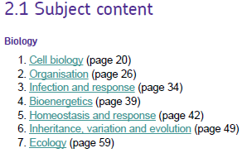
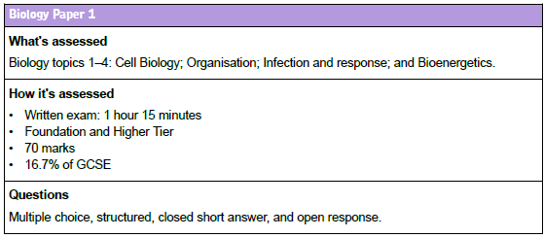
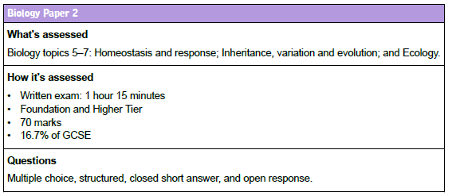
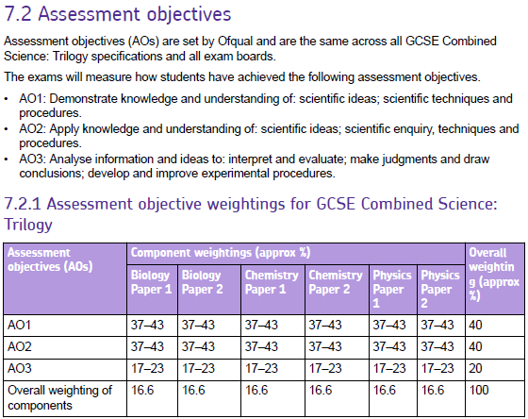
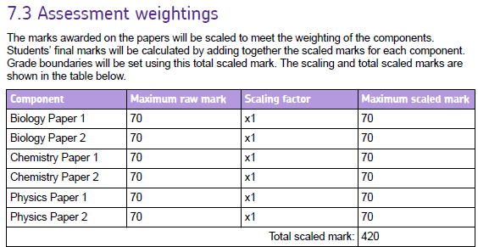
GRADES
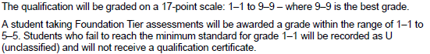
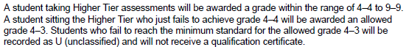
BIOLOGY TRILOGY REVISION ADVICE use the revision guide and Kerboodle text book
1.Read each section, ensure understanding
2. Make summary cards, include key points, key words and definitions, write questions and answers.
3. Draw diagrams and label parts, annotate with the functions (e.g., cell parts, heart, eye...)
4. Draw a mind map for the topic.
5. Answer questions. Check and correct your answers (revision guide in book, Text book from Doddle document with all the Student text book answers). Test yourself.
6. Write a model answer especially for 4-6 markers.( using the mark scheme )
7. Learn the key vocabulary for each topic, convert onto a diagram to help you remember what it means. (Glossaries for all the units are in the doddle document called student book answers and glossaries)
8. Then do the practice exam questions for the topic revised. Mark using mark scheme
9. Make a list of things not understood and see teacher.
10.Revising all content at least 3 times
11. Practice papers form revision guide and down load papers from the old spec and sample papers from AQA.
REMEMBER YOUR MATHS
Standard form e.g. 20000 is 2 X 10⁴
Significant figures e.g. 3 sig fig is 1.26, 2 significant figures is 1.3.
Calculate means.
Draw graphs, using correct scale, plot accurately and draw lines/ curves of best fit, label axes, include units.
Calculate rates of reactions from tables and graphs
Use correct units
Calculate percentage change
REMEMBER the Required practicals : use your booklet
Identify : variables
Independent- what you change
Dependent – what you measure
Control- what we keep the same to ensure a fair test and how, e.g wter baths to keep temperature constant, ensure tubes are left at the correct temperature to reach the correct temperature before mixing…
How to collect accurate and reliable data
How to improve method.
