Q1.
A student investigated her reaction time.
A computer measured how quickly she clicked the mouse when she detected each of three different stimuli as shown in the diagrams.
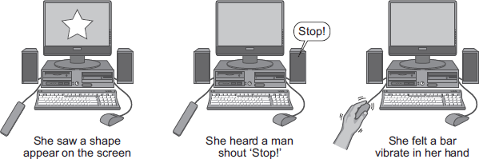
(a) Give the stimulus each sense organ detected in this investigation.
Complete each sentence using the correct word from the box.

chemicals | light | sound | touch
Receptors in her eyes detected ____________________________ .
Receptors in her ears detected ____________________________ .
Receptors in her skin detected ____________________________ .
(3)
(b) Each sense organ was tested 4 times and the mean reaction times were calculated.
The table shows the results.

 | Reaction time for each sense organ in seconds
 | Eyes | Ears | Skin
Test 1 | 0.23 | 0.17 | 0.18
Test 2 | 0.27 | 0.14 | 0.16
Test 3 | 0.24 | 0.15 | 0.35
Test 4 | 0.26 | 0.14 | 0.17
Mean reaction time |  | 0.15 | 0.17
(i) There is one anomalous result in the table.
Draw a ring around the anomalous result.
(1)
(ii) Calculate the mean reaction time for the eyes.
______________________________________________________________
______________________________________________________________
Mean reaction time for the eyes = ____________________ seconds
(2)
(iii) Give one conclusion you can make from these results.
______________________________________________________________
______________________________________________________________
(1)
(Total 7 marks)
Q2.
The diagram shows the structures involved in a reflex action.
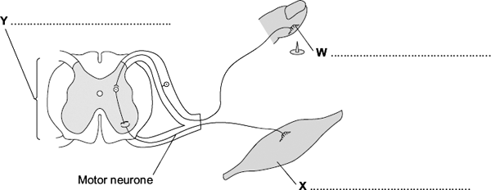
(a) On the diagram, name the structures labelled W, X and Y.
(3)
(b) The control of blood sugar level is an example of an action controlled by hormones.
Give two ways in which a reflex action is different from an action controlled by hormones.
1. _________________________________________________________________
___________________________________________________________________
___________________________________________________________________
2. _________________________________________________________________
___________________________________________________________________
___________________________________________________________________
(2)
(Total 5 marks)
Q3.
Information is passed to target organs in the body by hormones.
(a) (i) How do hormones travel around the body?
______________________________________________________________
(1)
(ii) What name is given to the organs that secrete hormones?
______________________________________________________________
(1)
(b) Explain the cause of diabetes and how it is controlled.
___________________________________________________________________
___________________________________________________________________
___________________________________________________________________
___________________________________________________________________
(3)
(Total 5 marks)
Q4.
The number of cases of Type 2 diabetes in the UK is increasing rapidly.
(a) Describe how insulin and glucagon help control the blood sugar concentration in a healthy person.
___________________________________________________________________
___________________________________________________________________
___________________________________________________________________
___________________________________________________________________
___________________________________________________________________
___________________________________________________________________
___________________________________________________________________
___________________________________________________________________
___________________________________________________________________
___________________________________________________________________
___________________________________________________________________
___________________________________________________________________
___________________________________________________________________
___________________________________________________________________
(6)
(b) What is Type 2 diabetes?
___________________________________________________________________
___________________________________________________________________
(1)
(c) Body mass index (BMI) is a person’s body weight divided by the square of his or her height.
(i) Graph 1 shows the relationship between BMI and the percentage probability of developing Type 2 diabetes.
Graph 1
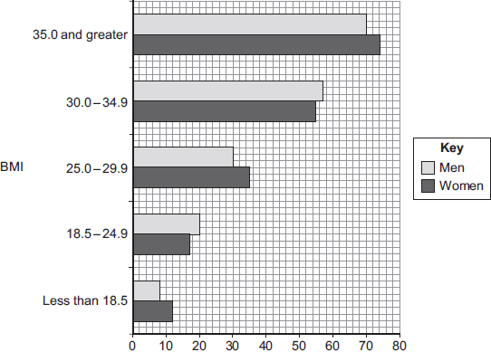
Percentage probability of developing Type 2 diabetes
Suggest an explanation for the relationship between BMI and the risk of developing Type 2 diabetes.
______________________________________________________________
______________________________________________________________
______________________________________________________________
______________________________________________________________
(2)
(ii) Graph 2 shows changes in the number of new cases of Type 2 diabetes in the UK.
Graph 2
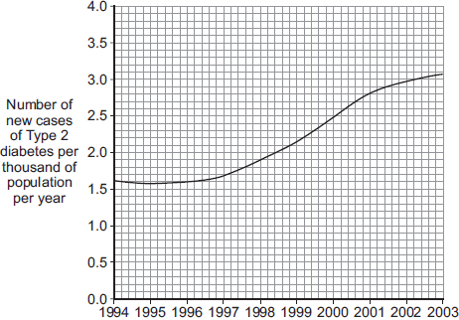
Year
Suggest explanations for the trend shown by the data in Graph 2.
______________________________________________________________
______________________________________________________________
______________________________________________________________
______________________________________________________________
______________________________________________________________
______________________________________________________________
(3)
(Total 12 marks)
Q5.
The human body produces many hormones.
(a) (i) What is a hormone?
______________________________________________________________
______________________________________________________________
(1)
(ii) Name an organ that produces a hormone.
______________________________________________________________
(1)
(iii) How are hormones transported to their target organs?
______________________________________________________________
(1)
(b) Describe how the hormones FSH, oestrogen and LH are involved in the control of the menstrual cycle.
___________________________________________________________________
___________________________________________________________________
___________________________________________________________________
___________________________________________________________________
___________________________________________________________________
___________________________________________________________________
___________________________________________________________________
___________________________________________________________________
(3)
(Total 6 marks)
Q6.
The graph shows changes in the levels of three hormones in a menstrual cycle.
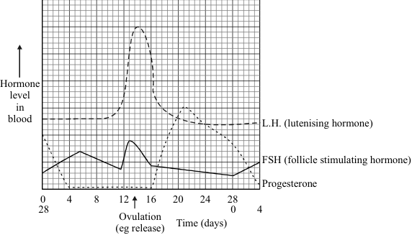
(a) What does the graph suggest the stimuli might be which cause the egg to be released?
___________________________________________________________________
___________________________________________________________________
___________________________________________________________________
___________________________________________________________________
(3)
(b) One type of contraceptive pill keeps the level of progesterone high for most of the cycle.
Suggest how this might work.
___________________________________________________________________
___________________________________________________________________
___________________________________________________________________
(2)
(c) Outline two arguments for and two against using hormones as contraceptives.
For: 1 ______________________________________________________
_______________________________________________________
For: 2 ______________________________________________________
_______________________________________________________
Against: 1 ______________________________________________________
_______________________________________________________
Against: 2 ______________________________________________________
_______________________________________________________
(4)
(Total 9 marks)

Q7.
Hormones can be used to control a woman’s fertility.
(a) The first birth control pills contained only oestrogen.
Name another hormone now used in modern birth control pills.
___________________________________________________________________
Give an advantage of using this hormone.
___________________________________________________________________
___________________________________________________________________
(2)
(b) Hormones control a woman’s menstrual cycle.
Graph 1 shows how the concentrations of hormones change during one menstrual cycle.
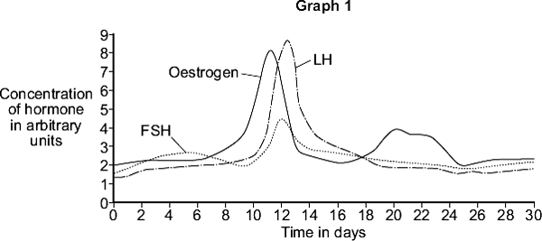
Graph 2 shows how a woman’s body temperature changes during one menstrual cycle.
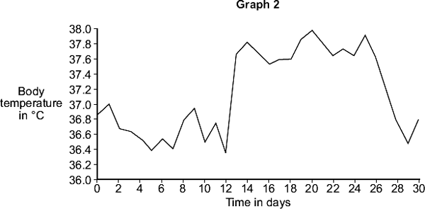
How could a woman use body temperature measurements to find the best time of the month to have sexual intercourse to get pregnant?
Use information from Graph 1 and Graph 2 to explain your answer.
___________________________________________________________________
___________________________________________________________________
___________________________________________________________________
___________________________________________________________________
___________________________________________________________________
___________________________________________________________________
___________________________________________________________________
___________________________________________________________________
(4)
(Total 6 marks)
Mark schemes
Q1.
(a) light
must be in correct order
allow light waves
1
sound
allow sound waves
1
touch
1
(b) (i) 0.35 in skin column circled
only look at figures in table more than one figure circled negates mark
ignore values written in table for mean reaction time for eyes
1
(ii) 0.25 (seconds)
allow 1 mark for
or 1 / 4
2
(iii) any one from:
ignore figures / references to sensitivity
• the ears / sound had the shortest reaction time
allow fastest
• the eyes / light had the longest reaction time
allow slowest
• ears and skin had similar reaction times
ignore references to anomalies or repeat values
1
[7]
Q2.
(a) Y - spinal cord / central nervous system / CNS
do not accept spine
ignore nerve / nervous system / coordinator
ignore grey / white matter
1
W - receptor / nerve ending
ignore sensory / neurone / stimulus
1
X - effector / muscle
allow gland
1
(b) any two from: eg
accept reverse argument for each marking point
• reflex action quicker
• effect of reflex action over shorter period
• hormone involves blood system and reflex involves neurones / nerve cells
ignore nervous system / nerves
• reflex involves impulses and hormone involves chemicals
• reflex action affects only one part of the body
ignore involves brain
ignore outside / inside stimuli
2
[5]
Q3.
(a) (i) in blood or the circulation system or plasma
accept arteries and veins or blood vessels
do not accept slowly or in blood cells
1
(ii) glands
accept endocrine glands or endocrine
do not accept a named gland
1
(b) the pancreas
accept islets of Langerhans
1
any one from
does not produce (sufficient) insulin
(blood) sugar is not (properly) controlled
1
insulin injections or inhalers
accept diet or tablets to make the
pancreas produce insulin
1
[5]
Q4.
(a) any six from:
• hormone(s) / named produced by pancreas
• if blood glucose levels are too high, insulin is produced / released
• allowing glucose to move from the blood into the cells / named eg liver
• glucose is converted to glycogen
• if blood glucose levels fall, glucagon is produced / released
• glycogen is converted to glucose
• causing glucose to be released into the blood
6
(b) diabetes that occurs when the body (cells) do not respond / are less responsive to insulin
1
(c) (i) higher BMIs due to increase in mass / weight (relative to height) / obesity
1
obesity / being overweight / being fat is a (significant) risk factor for Type 2 diabetes
allow causes Type 2 diabetes
1
(ii) any three from:
• related to described change in diet eg fast foods
• and less exercise
• which increases the chance of obesity / increases BMI
• increased awareness has helped to slow the increase
3
[12]
Q5.
(a) (i) any one from:
• chemical messenger / message
allow substance / material which is a messenger
• chemical / substance produced by a gland
allow material produced by a gland
• chemical / substance transported to / acting on a target organ
• chemical / substance that controls body functions
1
(ii) gland / named endocrine gland
brain alone is insufficient
allow phonetic spelling
1
(iii) in blood / plasma or circulatory system or bloodstream
accept blood vessels / named
do not accept blood cells / named
1
(b) each hormone must be linked to correct action
apply list principle
ignore the gland producing hormone
FSH stimulates oestrogen (production) / egg maturation / egg ripening
ignore production / development of egg
1
oestrogen inhibits FSH
allow oestrogen stimulates LH / build up of uterine lining
1
LH stimulates egg / ovum release / ovulation
accept LH inhibits oestrogen
accept LH controls / stimulates
growth of corpus luteum
ignore production of egg
1
[6]
Q6.
(a) LH or FSH (only one mentioned)
gains 1 mark
but
LH and/or FSH (both mentioned)
gains 2 marks
rises (sharply)
for 1 further mark
3
(b) FSH or LH level kept low
no ovulation/egg not released
for 1 mark each
2
(c) for:
very effective/prescribed/
personal preference/convenient/
promote family values
any two for 1mark each
against:
upset internal environment
named side effects (allow two)
religious belief
no protection against VD/AIDS
long-term effects
moral belief
any two for 1 mark each
4
[9]
Q7.
(a) progesterone
1
fewer / less side effects
allow named side effect
eg less chance of nausea / headaches / blood clots / high blood pressure
second mark only awarded if correct hormone given
if no hormone given second mark can be awarded
1
(b) (sharp / sudden / large) temperature increase
allow correct figures
eg 36.4–37.6 / 37.8
1
(when) LH peaks / is high
allow peak of FSH / oestrogen / hormones
1
LH / luteinising hormone causes ovulation / egg release
1
(therefore) high chance of egg being there to be fertilised
1
[6]

