Q1. The figure below shows a student before and after a bungee jump.
The bungee cord has an unstretched length of 20.0 m.
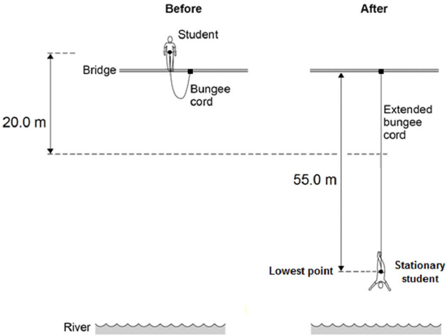
The mass of the student is 50.0 kg.
The gravitational field strength is 9.8 N / kg.
(a) Write down the equation which links gravitational field strength, gravitational potential energy, height and mass.
___________________________________________________________________
(1)
(b) Calculate the change in gravitational potential energy from the position where the student jumps to the point 20.0 m below.
___________________________________________________________________
___________________________________________________________________
___________________________________________________________________
Change in gravitational potential energy = _____________ J
(2)
(c) 80% of this change in gravitational potential energy has been transferred to the student’s kinetic energy store.
How much has the student’s kinetic energy store increased after falling 20.0 m?
Kinetic energy gained = ________________________ J
(1)
(d) Calculate the speed of the student after falling 20.0 m.
Give your answer to two significant figures.
___________________________________________________________________
___________________________________________________________________
___________________________________________________________________
___________________________________________________________________
Speed = __________________________ m / s
(4)
(e) At the lowest point in the jump, the energy stored by the stretched bungee cord is 24.5 kJ.
The bungee cord behaves like a spring.
Calculate the spring constant of the bungee cord.
Use the correct equation from the Physics Equation Sheet.
___________________________________________________________________
___________________________________________________________________
___________________________________________________________________
___________________________________________________________________
___________________________________________________________________
___________________________________________________________________
Spring constant = ________________________ N / m
(3)
(Total 11 marks)
Q2. (a) The diagram shows how much heat is lost each second from different parts of an uninsulated house.
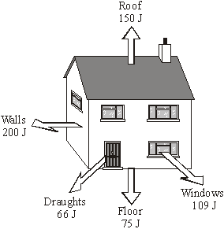
(i) Each year, the house costs £760 to heat.
How much money is being wasted because of heat lost through the roof?
Show clearly how you work out your answer.
______________________________________________________________
______________________________________________________________
(2)
(ii) Insulating the loft would cut the heat lost through the roof by 50 %.
The loft insulation has a payback time of years.
How much did the loft insulation cost to buy?
______________________________________________________________
Cost of loft insulation = £ _________________________
(1)
(b) What happens to the wasted energy?
___________________________________________________________________
___________________________________________________________________
(1)
(Total 4 marks)
Q3. Solar panels are often seen on the roofs of houses.
(a) Describe the action and purpose of a solar panel.
___________________________________________________________________
___________________________________________________________________
___________________________________________________________________
___________________________________________________________________
(2)
(b) Photovoltaic cells transfer light energy to electrical energy.
In the UK, some householders have fitted modules containing photovoltaic cells on the roofs of their houses.
Four modules are shown in the diagram.
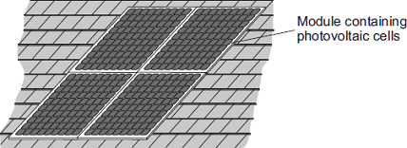
The electricity company pays the householder for the energy transferred.
The maximum power available from the photovoltaic cells shown in the diagram is 1.4 × 10³ W.
How long, in minutes, does it take to transfer 168 kJ of energy?
___________________________________________________________________
___________________________________________________________________
___________________________________________________________________
___________________________________________________________________
___________________________________________________________________
___________________________ Time = ____________________ minutes
(3)
(c) When the modules are fitted on a roof, the householder gets an extra electricity meter to measure the amount of energy transferred by the photovoltaic cells.
(i) The diagram shows two readings of this electricity meter taken three months apart.
The readings are in kilowatt-hours (kWh).

21 November | 0 | 0 | 0 | 4 | 4

21 February | 0 | 0 | 1 | 9 | 4
Calculate the energy transferred by the photovoltaic cells during this time period.
______________________________________________________________
Energy transferred = ____________________ kWh
(1)
(ii) The electricity company pays 40p for each kWh of energy transferred.
Calculate the money the electricity company would pay the householder.
______________________________________________________________
______________________________________________________________
Money paid = ____________________
(2)
(iii) The cost of the four modules is £6000.
Calculate the payback time in years for the modules.
______________________________________________________________
______________________________________________________________
Payback time = ____________________ years
(3)
(iv) State an assumption you have made in your calculation in part (iii).
______________________________________________________________
______________________________________________________________
(1)
(d) In the northern hemisphere, the modules should always face south for the maximum transfer of energy.
State one other factor that would affect the amount of energy transferred during daylight hours.
___________________________________________________________________
___________________________________________________________________
(1)
(Total 13 marks)
Q4. A 12 V filament bulb is connected to a 12 V power supply.
The graph shows how the current changes after the bulb is switched on.
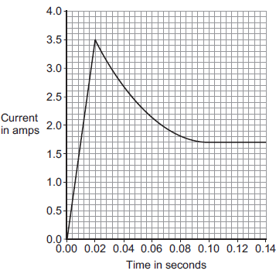
(a) (i) After 0.10 seconds, the bulb works at its normal brightness.
What is the current through the bulb when it is working at normal brightness?
Current = _____________________ A
(1)

(ii) The bulb works at normal brightness for 30 seconds before it is switched off.
Calculate the charge that flows through the bulb in the 30 seconds before it is switched off. Give the unit.
______________________________________________________________
______________________________________________________________
______________________________________________________________
Charge = _________________ unit _________________
(3)
(iii) Calculate the energy transferred by the 12 V bulb when it is working at normal brightness for 30 seconds.
______________________________________________________________
______________________________________________________________
Energy transferred = _____________________ J
(2)
(b) Between 0.02 seconds and 0.08 seconds, there is an increase in both the resistance and the temperature of the metal filament inside the bulb.
Explain, in terms of the electrons and ions inside the filament, why both the temperature and the resistance increase.
___________________________________________________________________
___________________________________________________________________
___________________________________________________________________
___________________________________________________________________
___________________________________________________________________
___________________________________________________________________
(2)
(Total 8 marks)
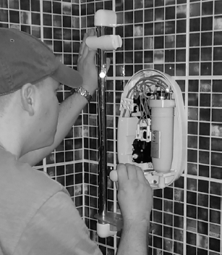
Q5. An electrician is replacing an old electric shower with a new one.
The inside of the old shower is shown in Figure 1.

(a) If the electrician touches the live wire he will receive an electric shock.
Explain why.
___________________________________________________________________
___________________________________________________________________
___________________________________________________________________
___________________________________________________________________
___________________________________________________________________
___________________________________________________________________
___________________________________________________________________
___________________________________________________________________
(4)
(b) Different electrical wires need to have a cross-sectional area that is suitable for the power output.
Figure 2 shows the recommended maximum power input to wires of different cross-sectional areas.
Figure 2
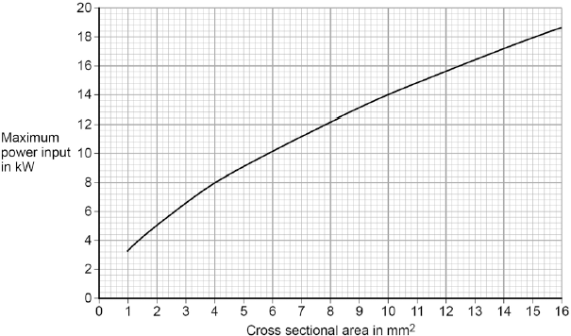
The new electric shower has a power input of 13.8 kW.
Determine the minimum diameter of wire that should be used for the new shower.
The diameter, d, can be calculated using the equation:
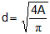
A is the cross-sectional area of the wire.
___________________________________________________________________
___________________________________________________________________
Minimum diameter = _________________________ mm
(2)
(c) The charge that flows through the new shower in 300 seconds is 18 000 C.
The new electric shower has a power of 13.8 kW.
Calculate the resistance of the heating element in the new shower.
Write down any equations you use.
___________________________________________________________________
___________________________________________________________________
___________________________________________________________________
___________________________________________________________________
___________________________________________________________________
___________________________________________________________________
___________________________________________________________________
Resistance = _______________________ Ω
(5)
(Total 11 marks)
Q6. According to kinetic theory, all matter is made up of small particles. The particles are constantly moving.
Diagram 1 shows how the particles may be arranged in a solid.
Diagram 1
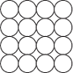
(a) One kilogram of a gas has a much larger volume than one kilogram of a solid.
Use kinetic theory to explain why.
___________________________________________________________________
___________________________________________________________________
___________________________________________________________________
___________________________________________________________________
___________________________________________________________________
___________________________________________________________________
___________________________________________________________________
___________________________________________________________________
___________________________________________________________________(4)
(b) Diagram 2 shows the particles in a liquid. The liquid is evaporating.
Diagram 2
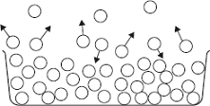
(i) How can you tell from Diagram 2 that the liquid is evaporating?
______________________________________________________________
______________________________________________________________
(1)
(ii) The temperature of the liquid in the container decreases as the liquid evaporates.
Use kinetic theory to explain why.
______________________________________________________________
______________________________________________________________
______________________________________________________________
______________________________________________________________
______________________________________________________________
______________________________________________________________
______________________________________________________________
______________________________________________________________
(3)
(Total 8 marks)
Q7.A student models the random nature of radioactive decay using 100 dice.
He rolls the dice and removes any that land with the number 6 facing upwards.
He rolls the remaining dice again.
The student repeats this process a number of times.
The table below shows his results.

Roll number | Number of dice remaining
0 | 100
1 | 84
2 | 70
3 | 59
4 | 46
5 | 40
6 | 32
7 | 27
8 | 23
(a) Give two reasons why this is a good model for the random nature of radioactive decay.
1. _________________________________________________________________
___________________________________________________________________
2. _________________________________________________________________
___________________________________________________________________
(2)
(b) The student’s results are shown in Figure 1.
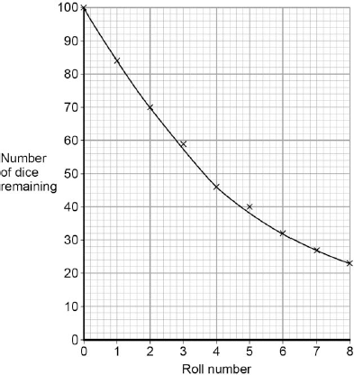
Use Figure 1 to determine the half-life for these dice using this model.
Show on Figure 1 how you work out your answer.
Half-life = ________________________ rolls
(2)
(c) A teacher uses a protactinium (Pa) generator to produce a sample of radioactive material that has a half-life of 70 seconds.
In the first stage in the protactinium generator, uranium (U) decays into thorium (Th) and alpha (α) radiation is emitted.
The decay can be represented by the equation shown in Figure 2.
Figure 2
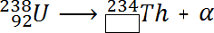
Determine the atomic number of thorium (Th) 234.
Atomic number = ______________________
(1)
(d) When protactinium decays, a new element is formed and radiation is emitted.
The decay can be represented by the equation shown in Figure 3.
Figure 3
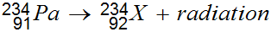
When protactinium decays, a new element, X, is formed.
Use information from Figure 2 and Figure 3 to determine the name of element X.
___________________________________________________________________
(1)
(e) Determine the type of radiation emitted as protactinium decays into a new element.
Give a reason for your answer.
___________________________________________________________________
___________________________________________________________________
___________________________________________________________________
___________________________________________________________________
(2)
(f) The teacher wears polythene gloves as a safety precaution when handling radioactive materials.
The polythene gloves do not stop the teacher’s hands from being irradiated.
Explain why the teacher wears polythene gloves.
___________________________________________________________________
___________________________________________________________________
___________________________________________________________________
___________________________________________________________________
(2)
(Total 10 marks)

