Q1. When you transfer energy to a shopping trolley, the amount of work done depends on the force used and the distance moved.
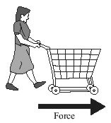
Complete the table by using the correct units from the box.

joule (J) metre (m) newton (N)
The first one has been done for you.
Quantity | Unit
energy (transferred) | joule
force
distance (moved)
work done
(Total 2 marks)
Q2. (a) The diagram shows two switches on a room heater. The heater has three power settings. The power produced by two of the settings is given in the table.

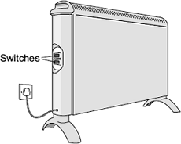
 | Setting | Power in kW
 | Low | 0.5
 | Medium | 1.5
 | High
(i) When both switches are on, the heater works at the high power setting.
What is the power of the heater, in kilowatts, when it is switched to the high power setting?
______________________________________________________________
Power = _____________________________ kilowatts
(1)
(ii) The heater is used on the high power setting. It is switched on for 1½ hours.
Calculate the energy transferred from the mains to the heater in 1½ hours.
Show clearly how you work out your answer and give the unit.
______________________________________________________________
______________________________________________________________
______________________________________________________________
Energy transferred = __________________________
(3)
(iii) This type of heater is a very efficient device.
What is meant by a device being very efficient?
______________________________________________________________
______________________________________________________________
(1)
(b) The graph shows how the temperature of a room changes during the 1½ hours that the heater is used.
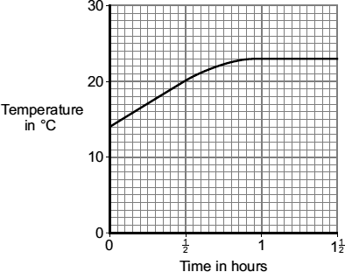
After 1 hour, the temperature of the room has become constant, even though the heater is still switched on.
Explain why.
___________________________________________________________________
___________________________________________________________________
___________________________________________________________________
___________________________________________________________________
(2)
(Total 7 marks)
Q3. Diagram 1 shows the energy transferred per second from a badly insulated house on a cold day in winter.
Diagram 1
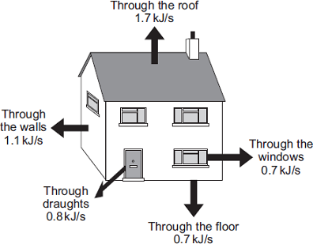
(a) (i) When the inside of the house is at a constant temperature, the energy transferred from the heating system to the inside of the house equals the energy transferred from the house to the outside.
Calculate, in kilowatts, the power of the heating system used to keep the inside of the house in Diagram 1 at a constant temperature.
1 kilowatt (kW) = 1 kilojoule per second (kJ/s)
______________________________________________________________
Power of the heating system = ___________________________ kW
(1)
(ii) In the winter, the heating system is switched on for a total of 7 hours each day.
Calculate, in kilowatt-hours, the energy transferred each day from the heating system to the inside of the house.
______________________________________________________________
______________________________________________________________
Energy transferred each day = ___________________________ kWh
(2)

(iii) Energy costs 15 p per kilowatt-hour.
Calculate the cost of heating the house for one day.
______________________________________________________________
Cost = _______________
(1)
(iv) The heating system is switched off at midnight.
The graph shows how the temperature inside the house changes after the heating system has been switched off.
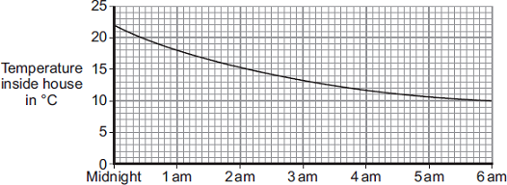
Time of day
Draw a ring around the correct answer in the box to complete the sentence.
Between midnight and 6 am the rate of energy transfer from

 | decreases.
the house | decreases then stays constant.
 | increases.
Give the reason for your answer.
______________________________________________________________
______________________________________________________________
(2)

(b) Diagram 2 shows how the walls of the house are constructed.
Diagram 3 shows how the insulation of the house could be improved by filling the air gap between the two brick walls with plastic foam.

Diagram 2 | Diagram 3
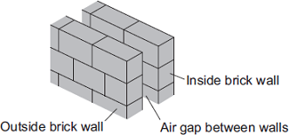 | 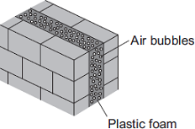
U-value of the wall = 0.7 | U-value of the wall = 0.3
The plastic foam reduces energy transfer by convection.
Explain why.
___________________________________________________________________
___________________________________________________________________
___________________________________________________________________
___________________________________________________________________
(2)
(Total 8 marks)
Q4 Electricity can be generated using various energy sources.
(a) Give one advantage and one disadvantage of using nuclear power stations rather than gas-fired power stations to generate electricity.
Advantage __________________________________________________________
___________________________________________________________________
Disadvantage _______________________________________________________
___________________________________________________________________
(2)
(b) (i) A single wind turbine has a maximum power output of 2 000 000 W.
The wind turbine operated continuously at maximum power for 6 hours.
Calculate the energy output in kilowatt-hours of the wind turbine.
______________________________________________________________
______________________________________________________________
______________________________________________________________
Energy output = ____________________ kWh
(2)
(ii) Why, on average, do wind turbines operate at maximum power output for only 30% of the time?
______________________________________________________________
______________________________________________________________
(1)
(c) An on-shore wind farm is made up of many individual wind turbines.
They are connected to the National Grid using underground power cables.
Give one advantage of using underground power cables rather than overhead power cables.
___________________________________________________________________
___________________________________________________________________
(1)
(Total 6 marks)
Q5. A student set up the electrical circuit shown in the figure below.
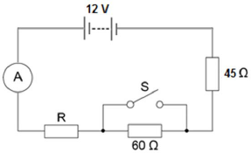
(a) The ammeter displays a reading of 0.10 A.
Calculate the potential difference across the 45 Ω resistor.
___________________________________________________________________
___________________________________________________________________
Potential difference = _______________________ V
(2)
(b) Calculate the resistance of the resistor labelled R.
___________________________________________________________________
___________________________________________________________________
___________________________________________________________________
Resistance = _______________________ Ω
(3)

(c) State what happens to the total resistance of the circuit and the current through the circuit when switch S is closed.
___________________________________________________________________
___________________________________________________________________
___________________________________________________________________
___________________________________________________________________
(2)
(Total 7 marks)
Q6. (a) An adaptor can be used to connect up to four appliances in parallel to one 230 V mains socket. The adaptor is fitted with a 13 A fuse. The table gives a list of appliances and the current they draw from a mains socket.
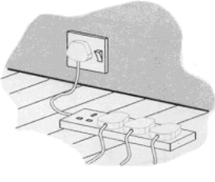

Appliance | Current
computer | 1 A
hairdryer | 4 A
heater | 8 A
iron | 6 A
television | 2 A
(i) What current will flow to the adaptor when the television, computer and hairdryer are plugged into the adaptor?
______________________________________________________________
Current = _________________ A
(1)
(ii) Write down the equation which links current, electrical power and voltage.
______________________________________________________________
(1)

(iii) Calculate the electrical power used when the television, computer and hairdryer are plugged into the adaptor. Show clearly how you work out your answer and give the unit.
______________________________________________________________
______________________________________________________________
______________________________________________________________
Electrical power = ___________________
(2)
(iv) What would happen to the fuse if the heater is also plugged into the adaptor?
Give a reason for your answer.
______________________________________________________________
______________________________________________________________
(2)
(b) The diagram shows two of the appliances.
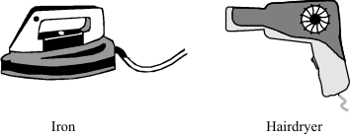
(i) For safety reasons, it is important that the iron has an earth wire connected to its outer metal case. Explain why.
______________________________________________________________
______________________________________________________________
______________________________________________________________
______________________________________________________________
(2)
(ii) The hairdryer does not have an earth wire. It is safe to use because it is double insulated. Explain what the term double insulated means.
______________________________________________________________
______________________________________________________________
______________________________________________________________
______________________________________________________________
(2)
(Total 10 marks)

Q7. Solid, liquid and gas are three different states of matter.
(a) Describe the difference between the solid and gas states, in terms of the arrangement and movement of their particles.
___________________________________________________________________
___________________________________________________________________
___________________________________________________________________
___________________________________________________________________
___________________________________________________________________
___________________________________________________________________
___________________________________________________________________
___________________________________________________________________
___________________________________________________________________
___________________________________________________________________
___________________________________________________________________
(4)
(b) What is meant by ‘specific latent heat of vaporisation’?
___________________________________________________________________
___________________________________________________________________
___________________________________________________________________
___________________________________________________________________
(2)
(c) While a kettle boils, 0.018 kg of water changes to steam.
Calculate the amount of energy required for this change.
Specific latent heat of vaporisation of water = 2.3 × 10⁶ J / kg.
___________________________________________________________________
___________________________________________________________________
___________________________________________________________________
Energy required = __________________ J
(2)

(d) The graph shows how temperature varies with time for a substance as it is heated.
The graph is not drawn to scale.
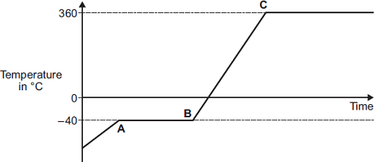
Explain what is happening to the substance in sections AB and BC of the graph.
Section AB _________________________________________________________
___________________________________________________________________
___________________________________________________________________
___________________________________________________________________
___________________________________________________________________
Section BC _________________________________________________________
___________________________________________________________________
___________________________________________________________________
___________________________________________________________________
___________________________________________________________________
(4)
(Total 12 marks)
Q8. Alpha particles, beta particles and gamma rays are types of nuclear radiation.
(a) Describe the structure of an alpha particle.
___________________________________________________________________
___________________________________________________________________
(1)

(b) Nuclear radiation can change atoms into ions by the process of ionisation.
(i) Which type of nuclear radiation is the least ionising?
Tick (✔) one box.

alpha particles
beta particles
gamma rays
(1)
(ii) What happens to the structure of an atom when the atom is ionised?
______________________________________________________________
______________________________________________________________
(1)
(c) People working with sources of nuclear radiation risk damaging their health.
State one precaution these people should take to reduce the risk to their health.
___________________________________________________________________
___________________________________________________________________
(1)
(d) In this question you will be assessed on using good English, organising information clearly and using specialist terms where appropriate.
The type of radiation emitted from a radioactive source can be identified by comparing the properties of the radiation to the properties of alpha, beta and gamma radiation.
Describe the properties of alpha, beta and gamma radiation in terms of their:
• penetration through materials
• range in air
• deflection in a magnetic field.
(6)
(Total 10 marks)

