**Year 9 Spanish**

**Spring Term**

**Homework booklet**

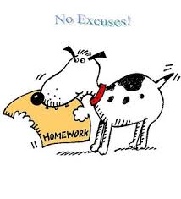

***Name: \_\_\_\_\_\_\_\_\_\_\_\_\_\_\_\_\_\_\_ Form: \_\_\_\_\_***

***Teacher: \_\_\_\_\_\_\_\_\_\_***

*Your teacher will tell you each week what you have to do and the due date. All pages are labelled. All instructions are in Spanish and English.*

*You will be expected to complete the homework tracker at the back yourself once each piece has been marked.*

**Vocabulario** in00447_

**Los deportes Sports**

¿Qué deportes practices?

What sports do you do?

Practico … I do/go …

el atletismo athletics

el ciclismo cycling

la equitación horse riding

el esquí skiing

la gimnasia gymnastics

la natación swimming

el patinaje skating

la vela sailing

el hockey hockey

Juego … I play …

Juega … He/She plays …

Juegan … They play …

… al bádminton badminton

… al baloncesto basketball

… al cricket cricket

… al fútbol football

… al rugby rugby

… al squash squash

… al tenis tennis

… al voleibol volleyball

Hago surfing. I go surfing.

Hago windsurf(ing). I go windsurfing.

**Los pasatiempos**

**Hobbies**

bailar dancing

cantar singing

cocinar cooking

escuchar música listening to music

hablar por teléfono talking on the

telephone

ir a la piscina going to the swimming

pool

ir al cine going to the cinema

polideportivo the sports centre

ir de compras going shopping

jugar con los playing video games

videojuegos

jugar con mi playing with my

Playstation Playstation

jugar con el playing on the

ordenador computer

leer reading

mandar mensajes sending text messages

montar a caballo going horse riding

navegar por Internet surfing the Internet

salir con mis amigos going out with my

friends

tocar la guitarra/ playing the guitar/

el piano piano

ver la tele(visión) watching television

**¿Qué te gusta hacer**

**en tu tiempo libre?**

**What do you like doing**

**in your free time?**

¿Te gusta (escuchar Do you like (listening

música)? to music)?

Me gusta (escuchar I like (listening to

música). music).

Me encanta … I love …

No me gusta … I don’t like …

Detesto/odio … I hate …

Prefiero … I prefer …

**¿Qué haces?**

**What do you do?**

Arreglo mi dormitorio. I tidy my room.

Hago deporte. I do sport.

Hago la cama. I make the bed.

Hago los deberes. I do my homework.

Juego a las cartas. I play cards.

Monto en bicicleta. I ride my bicycle.

Monto en monopatín. I go skateboarding.

Salgo con mis amigos. I go out with my

friends.

Toco la guitarra. I play the guitar.

Veo la televisión. I watch TV.

Voy a casa de mis I go to my

abuelos. grandparents.

Voy a la pista de hielo. I go to the ice rink.

Voy a la playa. I go to the beach.

Voy a un parque I go to a theme park.

temático.

Voy a un partido de I go to a football

fútbol. match.

Voy al campo. I go to the country.

Voy al cine. I go to the cinema.

Voy al instituto. I go to school.

**¿Qué hace?**

**What does he/she do?**

Voy de compras. I go shopping.

Arregla su dormitorio. He/She tidies his/her

room.

Hace deporte. He/She does sport.

Hace la cama. He/She makes his/her

bed.

Hace los deberes. He/She does his/her

homework.

Juega a las cartas. He/She plays cards.

Toca la guitarra. He/She plays the

guitar.

Va al instituto. He/She goes to school.

Ve la televisión. He/She watches TV.

a veces sometimes

los fines de semana (at) the weekends

todos los días every day

¡es divertido! it’s fun!

o or

mi my

su his/her/its/yours (usted)

tu your

**¿Quieres salir?**

**Do you want to go out?**

¿Dígame?/¿Diga? Hello (on answering

the phone)?

Soy (Pedro). It’s (Pedro).

¿Quieres ir (al cine)? Do you want to go (to

the cinema)?

¿Quieres jugar Do you want to play

(al tenis)? (tennis)?

**¿Cuándo y dónde?**

**When and where?**

Esta mañana/tarde. This morning/afternoon

(or evening)

Esta noche. Tonight.

Mañana. Tomorrow.

El (sábado). On (Saturday).

¿A qué hora? At what time?

a la(s) … at …

¿Dónde nos Where shall we meet?

encontramos?

en la plaza in the square

en mi casa at my house

en la entrada at the entrance

en la estación at the station

Bueno/Vale/ OK

De acuerdo/Bien

**Un mensaje**

**A text message**

Un abrazo A hug

Un beso A kiss

Besos Kisses

Saludos Regards/Best wishes

**¿Qué vas a hacer?**

**What are you going**

**to do?**

¿Qué vas a hacer este What are you going to

fin de semana? do this weekend?

Voy a (dormir/ver un I’m going to (sleep/

video). watch a video).

Voy a levantarme I’m going to get up

a las … at …

Voy a acostarme I’m going to go to bed

a las … at …

Van a … They’re going to …

por la mañana in the morning

por la noche at night

por la tarde in the afternoon/

evening

**¿Ayudas en casa?**

**Do you help at home?**

Barro el patio. I sweep the patio.

Cocino. I cook.

Friego los platos. I wash the dishes.

Hago la compra. I do the shopping.

Lavo el coche. I wash the car.

Paso la aspiradora. I hoover.

Plancho. I do the ironing.

Pongo la mesa. I lay the table.

Preparo la cena. I prepare supper/

dinner.

Quito la mesa. I clear the table.

Saco la basura. I put the rubbish out.

Ayudo un poco. I help a little.

No hago nada. I don’t do anything.

Nunca. Never.

¿Cómo vas a ayudar? How are you going to

help?

Voy a arreglar mi I’m going to tidy my

dormitorio/fregar room/wash the

los platos/cocinar … dishes/cook …

**Las tareas domésticas**

**Domestic chores**

arreglar mi dormitorio (to) tidy my room

barrer el patio (to) sweep the patio

cocinar (to) cook

fregar los platos (to) wash the dishes

hacer la compra (to) do the shopping

lavar el coche (to) wash the car

pasar la aspiradora (to) hoover

planchar (to) do the ironing

poner la mesa (to) lay the table

preparar la cena (to) prepare supper/

dinner

quitar la mesa (to) clear the table

sacar la basura (to) put the rubbish out

**¿Quieres ir? Do you want to go?**

al club de jóvenes to the youth club

a la pista de hielo to the ice rink

al cine to the cinema

al parque de atracciones to the amusement park

a la bolera to the bowling-alley

¿Cuándo? When?

esta mañana this morning

esta tarde this afternoon

esta noche this evening

mañana por la mañana tomorrow morning

mañana por la tarde tomorrow evening/afternoon

¿A qué hora (quedamos)? At what time (shall we meet)?

A las siete. At seven o’clock.

¿Dónde quedamos? Where shall we meet?

En la plaza In the square

En tu casa At your house

En la estación At the station

Bueno/Vale. Good/Ok.

Buena idea. Good idea.

**Las películas Films**

¿Qué tipo de películas What type of films

prefieres? do you prefer?

¿Te gustan las películas …? Do you like … films?

(No) Me gustan las I (don’t) like … películas … films.

Prefiero las películas … I prefer … films.

románticas romantic

cómicas comedy (comedies)

de ciencia-ficción sci-fi

de acción action

de terror horror

de dibujos animados animated (cartoons)

¿Por qué? Why?

Porque (no) son … Because they are

(aren’t) …

emocionantes exciting

aburridas boring

divertidas fun

infantiles childish

interesantes interesting

estúpidas stupid

**Dos entradas, por favor. Two tickets, please.**

¿Para qué película? For which film?

Para … For …

¿Para qué sesión? For which performance?

Para la sesión de … For the … performance.

Aquí tiene. Here they are/you are.

¿Cuánto es? How much is it?

Son … euros. It’s … euros.

Apta para … Suitable for …

todos los públicos all ages

mayores de … años … and over

**¿Dónde estás? Where are you?**

Estoy … I am …

en el parque zoológico at the zoological gardens

en el Museo del Prado at the Prado museum

en las montañas in the mountains

en el sur de España in the south of Spain

¿Con quién estás? Who are you with?

Estoy aquí con … I’m here with …

mis amigos my friends

mis padres my parents

mi(s) hermano(s) my brother(s)/brothers and sisters

**¿Qué tiempo hace? What is the weather like?**

Hace … It is …

buen tiempo good weather

mal tiempo bad weather

sol sunny

calor hot

frío cold

¿Cómo es? What is it like?

Es … It’s …

divertido fun

estupendo terrific

fenomenal fantastic

genial great

**¿Qué hiciste el sábado? What did you do on Saturday?**

Fui a … I went to …

un zoo a zoo

¿A qué hora saliste What time did you

de casa? leave home?

Salí de casa … I left home …

a las cinco y media at half past five

a las once at eleven

a la una at one

a las seis y media at six thirty

¿Cómo fuiste? How did you go?

Fui en … I went by …

tren train

autocar coach

coche car

¿Qué partido viste? What match did you see?

Vi un partido entre … I saw a match

between …

¿Qué comiste? What did you eat?

Comí … I ate …

patatas fritas french fries/chips

una hamburguesa a hamburger with con cebolla onions

un perrito caliente a hot dog

¿Qué bebiste? What did you drink?

Bebí … I drank …

un café con leche a white coffee

una naranjada an orangeade

¿A quién viste? Who did you see?

Vi a … I saw …

¿Qué tal el fin de semana? How was last weekend?

**¿Qué tiempo hacía? What was the weather like?**

Hacía … It was …

buen tiempo nice weather

mal tiempo bad weather

sol sunny

calor hot

frío cold

viento windy

¡Fue genial! It was great!

¡Fue un desastre! It was a disaster

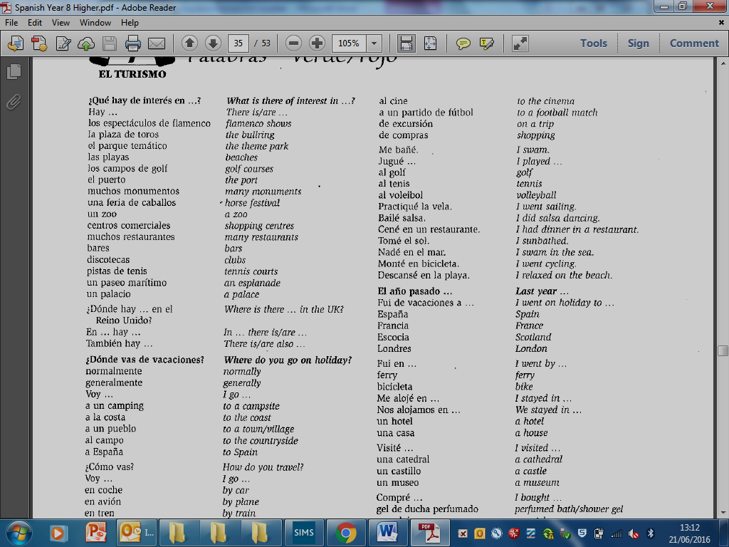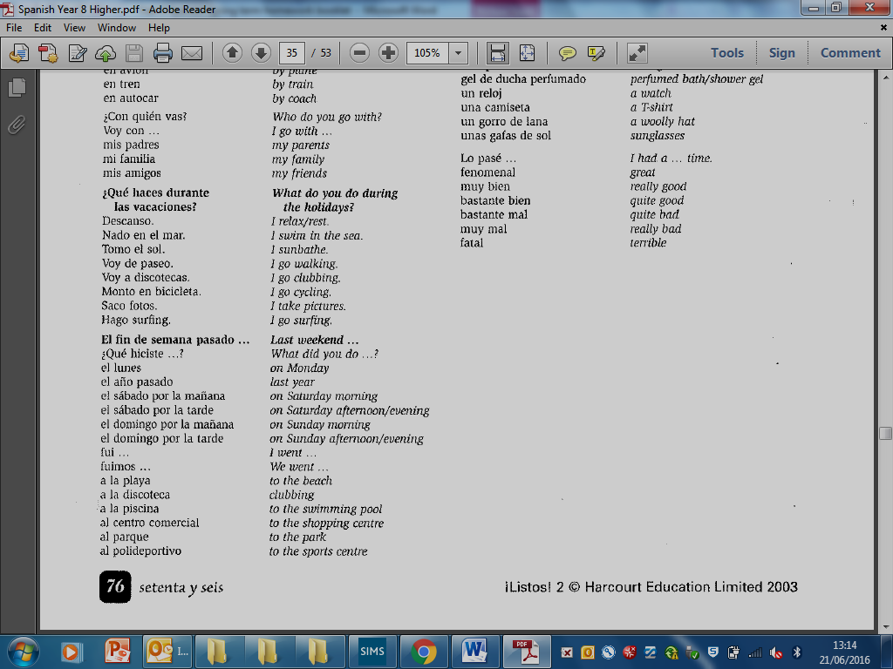

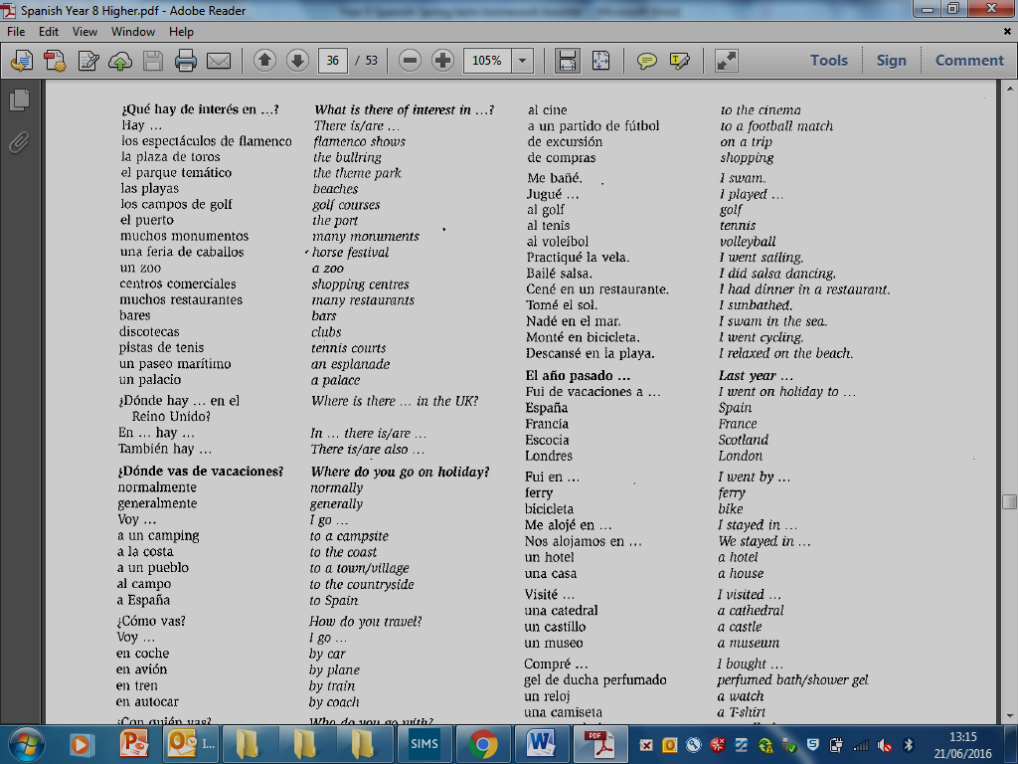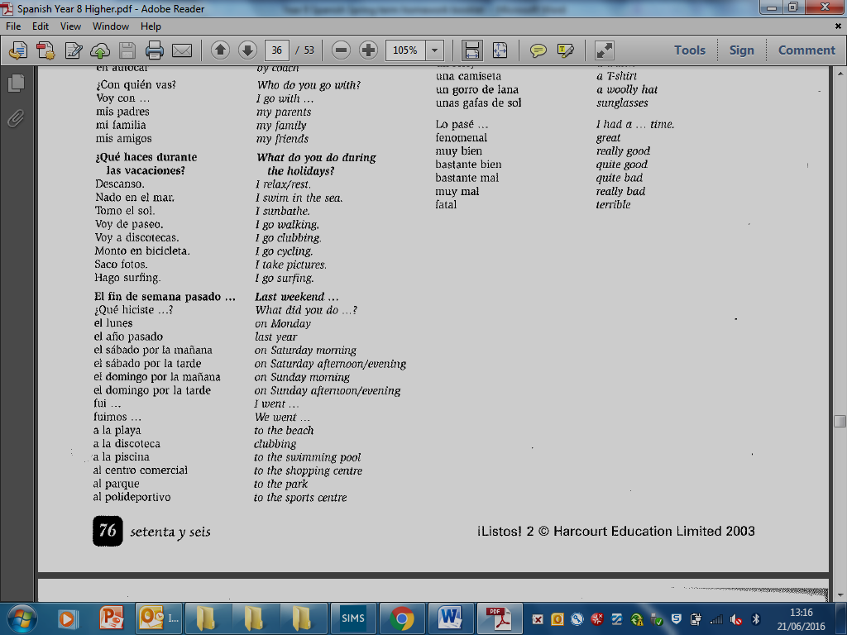

**Gramática**

**HOW USE THE PRESENT TENSE TO DESCRIBE AN EVENT**

|  |  |  |  |  |
| --- | --- | --- | --- | --- |
| **Estoy en** | el Parque Zoológico  el Museo del Prado  las Montañas  el sur de España | oooooo | **Hace** | buen tiempo  mal tiempo  sol  calor  frío |
| **Estoy con** | mis amigos  mis padres  mi(s) hermano(s) |  | **Es** | aburrido  divertido  estupendo  fenomenal  genial |

**HOW USE THE PAST TENSE TO DESCRIBE AN EVENT**

**REGULAR AR**

|  |  |
| --- | --- |
| **Visitar** | **To visit** |
| Visit**é** | I visited |
| Visit**aste** | You visited |
| Visit**ó** | He/she/it visited |
| Visit**amos** | We visited |
| Visit**ásteis** | You (pl) visited |
| Visit**aron** | They visited |

**REGULAR ER REGULAR IR**

|  |  |  |  |  |
| --- | --- | --- | --- | --- |
| **Comer** | **To eat** | **ooooooooo** | **Salir** | **To go out** |
| Com**í** | I ate |  | Sal**í** | I went out |
| Com**iste** | You ate |  | Sal**iste** | You went out |
| Com**ió** | He/she/it ate |  | Sal**ió** | He/she/it went out |
| Com**imos** | We ate |  | Sal**imos** | We went out |
| Com**isteis** | You (pl) ate |  | Sal**isteis** | You went out |
| Com**ieron** | They ate |  | Sal**ieron** | They went out |

**IRREGULAR VER IRREGULAR HACER**

|  |  |  |  |  |
| --- | --- | --- | --- | --- |
| **Ver** | **To see** | **ooooooooooo** | **Hacer** | **To do** |
| Vi | I saw |  | Hice | I did |
| Viste | You saw |  | Hiciste | You did |
| Vió | He/she/it saw |  | Hizo | He/she/it did |
| Vimos | We saw |  | Hicimos | We did |
| Visteis | You (pl) saw |  | Hicisteis | You (pl) did |
| Vieron | They saw |  | Hicieron | They did |

**VERBS**

**TO DO (a sport) TO PLAY**

|  |  |  |  |  |
| --- | --- | --- | --- | --- |
| **Practicar** | **To do** | **ooooooooooooooooooooooooo** | **Jugar** | **to play** |
| Practico | I do |  | Juego | I play |
| Practicas | You do |  | Juegas | You play |
| Practica | He/she/it does |  | Juega | He/she plays |
| practicamos | We do |  | Jugamos | We play |
| Practicáis | You (pl) do |  | Jugáis | You (pl) play |
| Practican | They do |  | Juegan | They play |

**HOW TO SAY “I like / I don’t like doing something”**

|  |  |
| --- | --- |
| verb | + infinitive |
| me encanta **j0424476[1] j0434713[1] j0434713[1]**    me gusta **j0424476[1] j0434713[1]**    no me gusta **j0423846[1] j0432537[1]**    odio / detesto **j0423846[1] j0432537[1] j0432537[1]** | escuchar música  ver la televisión  jugar al tenis |

**HOW TO SAY WHAT YOU ARE GOING TO DO AT THE WEEKEND**

|  |  |
| --- | --- |
| Use the verb IR + A + infinitive |  |
| Voy a  Vas a  Va a  Vamos a  Vais a  Van a | I am going to…  you are going to…  he / she / it is going to  we are going to  you (pl) are going to  they are going to |

**Parte 1: Las actividades y los pasatiemposdd01086_bd00173_**

**A) ¿Qué deportes practicas?**

**1. Empareja (match the pictures with the words from the box below).**

|  |  |  |  |  |  |  |  |
| --- | --- | --- | --- | --- | --- | --- | --- |
| **1** | **j0299763** | **2** | **j0240855[1]** | **3** | **j0398303[1]** | **1-\_\_\_\_\_\_\_\_\_\_\_\_\_**  **2-\_\_\_\_\_\_\_\_\_\_\_\_\_**  **3-\_\_\_\_\_\_\_\_\_\_\_\_\_**  **4-\_\_\_\_\_\_\_\_\_\_\_\_\_**  **5-\_\_\_\_\_\_\_\_\_\_\_\_\_** | **6-\_\_\_\_\_\_\_\_\_\_\_\_\_**  **7-\_\_\_\_\_\_\_\_\_\_\_\_\_\_**  **8-\_\_\_\_\_\_\_\_\_\_\_\_\_**  **9-\_\_\_\_\_\_\_\_\_\_\_\_\_** |
| **4** | **j0363044[1]** | **5** | **j0295610[1]** | **6** | **j0241899[1]** |
| **7** | **j0298685[1]** | **8** | **j0396718[1]** | **9** | **j0397116[1]** |

|  |  |  |
| --- | --- | --- |
| la vela | la equitación | el ciclismo |
| el esquí | la natación | el atletismo |
| el patinaje | la gimnasia | el fútbol |

**2. Escribe las frases en español (pick words and write the sentences in Spanish).**

|  |  |  |  |
| --- | --- | --- | --- |
| juego | practica | la | I play football: *Juego al fútbol*  I play basketball: \_\_\_\_\_\_\_\_\_\_\_\_\_\_\_\_\_\_\_\_\_\_\_\_\_\_\_\_\_\_\_\_  I do cycling:\_\_\_\_\_\_\_\_\_\_\_\_\_\_\_\_\_\_\_\_\_\_\_  He does gymnastics:\_\_\_\_\_\_\_\_\_\_\_\_\_\_\_\_\_  We do sailing:\_\_\_\_\_\_\_\_\_\_\_\_\_\_\_\_\_\_\_\_\_\_  We play tennis:\_\_\_\_\_\_\_\_\_\_\_\_\_\_\_\_\_\_\_\_\_ |
| al | baloncesto | la |
| practicamos | ~~fútbol~~ | al |
| el | tenis | cyclismo |
| jugamos | ~~al~~ | gimnasia |
| ~~juego~~ | vela | practico |
|  |  |  |
|  |  |  |

**B) ¿Qué te gusta hacer en tu tiempo libre?**

1. **Crucigrama (wordsearch).**

**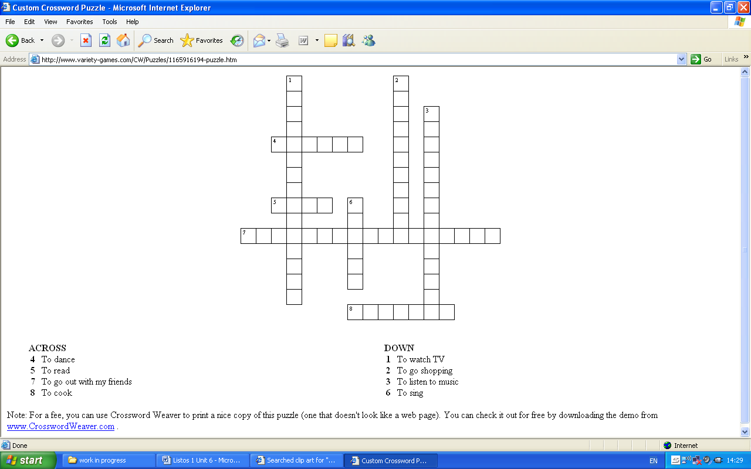**

****

**2. Escribe frases apropiadas (write sentences in Spanish to match the pictures).**

|  |  |
| --- | --- |
| **j0424476[1] j0434713[1] j0299763** | **\_\_\_\_\_\_\_\_\_\_\_\_\_\_\_\_\_\_\_\_\_\_\_\_\_\_\_\_\_\_\_** |
| **j0423846[1] j0432537[1] j0432517[1]** | **\_\_\_\_\_\_\_\_\_\_\_\_\_\_\_\_\_\_\_\_\_\_\_\_\_\_\_\_\_\_\_** |
| **j0424476[1] j0434713[1] j0434713[1]j0424240[1]** | **\_\_\_\_\_\_\_\_\_\_\_\_\_\_\_\_\_\_\_\_\_\_\_\_\_\_\_\_\_\_\_** |
| **j0424476[1]j0434713[1] j0241899[1]** | **\_\_\_\_\_\_\_\_\_\_\_\_\_\_\_\_\_\_\_\_\_\_\_\_\_\_\_\_\_\_\_\_** |
| **j0424476[1]j0434713[1]j0434713[1] j0410477[1]** | **\_\_\_\_\_\_\_\_\_\_\_\_\_\_\_\_\_\_\_\_\_\_\_\_\_\_\_\_\_\_\_\_** |
| **j0423846[1] j0432537[1] j0432537[1] j0397494[1]** | **\_\_\_\_\_\_\_\_\_\_\_\_\_\_\_\_\_\_\_\_\_\_\_\_\_\_\_** |

1. **Empareja (match-up)**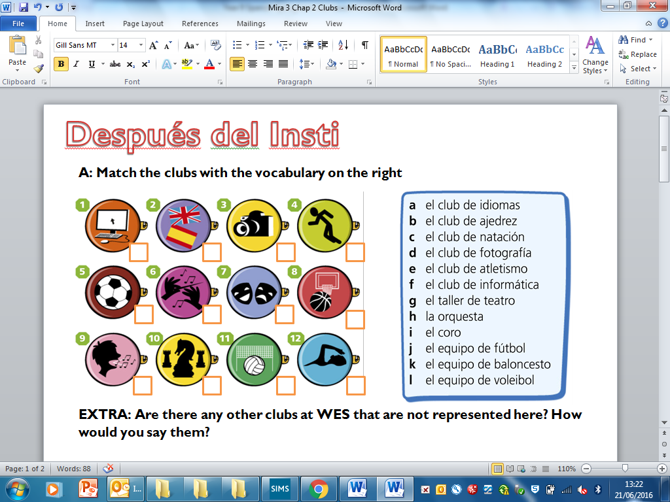

**\_\_\_\_\_\_\_\_\_\_\_\_\_\_\_\_\_\_\_\_\_\_\_\_\_\_\_\_\_\_\_\_\_\_\_\_\_\_\_\_\_\_\_\_\_\_\_\_\_\_\_\_\_\_\_\_\_\_\_\_\_\_\_\_\_\_\_\_\_\_\_\_\_\_\_\_\_\_\_\_\_\_\_\_\_\_\_\_**

1. **Escribe los clubes que faltan (at the end of each line write the club names that are missing in Spanish)**

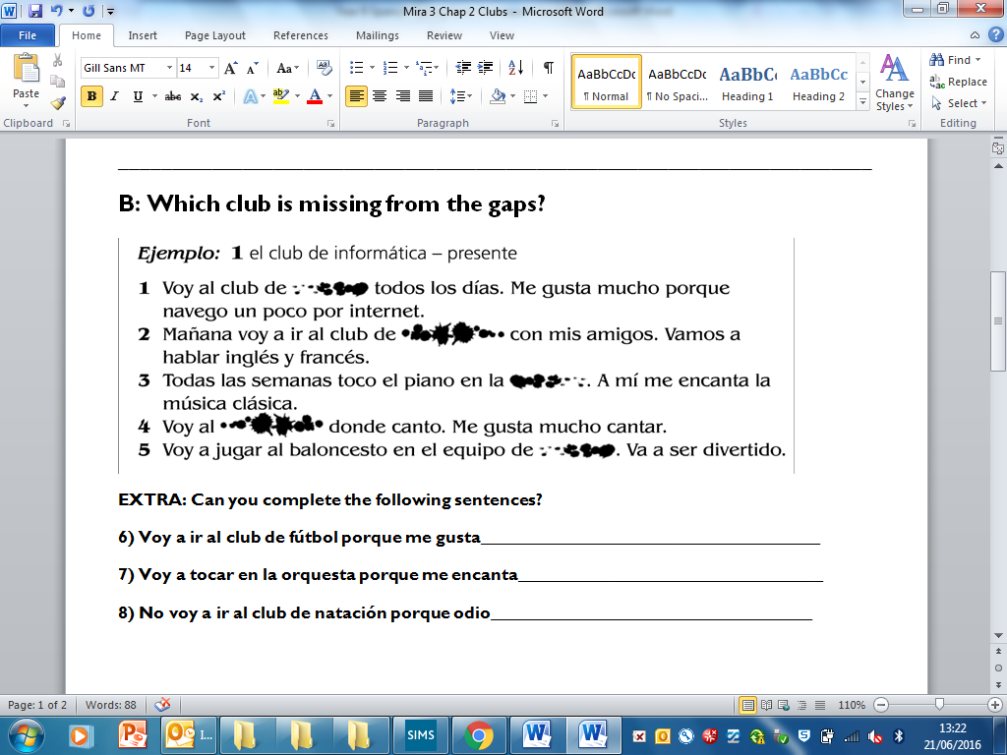

**C) ¿Qué haces los fines de semana?**

**1. Empareja (match the pictures to the activities).**

|  |  |  |  |  |  |  |
| --- | --- | --- | --- | --- | --- | --- |
| **1** | **j0319590[1]** | **2** | **j0232133[1]** | **3** | **j0396702[1]** | **1-\_\_\_\_\_\_\_\_\_\_\_\_\_\_\_\_\_\_**  **2-\_\_\_\_\_\_\_\_\_\_\_\_\_\_\_\_\_\_**  **3-\_\_\_\_\_\_\_\_\_\_\_\_\_\_\_\_\_\_**  **4-\_\_\_\_\_\_\_\_\_\_\_\_\_\_\_\_\_\_**  **5-\_\_\_\_\_\_\_\_\_\_\_\_\_\_\_\_\_\_**  **6-\_\_\_\_\_\_\_\_\_\_\_\_\_\_\_\_\_\_** |
| **4** | **j0432517[1]** | **5** | **j0433900[1]** | **6** | **j0412180[1]** |

|  |  |  |
| --- | --- | --- |
| Voy al instituto | Hago los deberes | Arreglo mi dormitorio |
| Juego a las cartas | Toco la guitarra | Veo la televisión |

1. **Completa las frases con las palabras apropiadas (complete the phrases with the appropriate words form the list).**

|  |  |  |  |  |  |  |  |  |  |
| --- | --- | --- | --- | --- | --- | --- | --- | --- | --- |
| De \_\_\_\_\_\_\_\_\_\_\_\_\_\_ a viernes me levanto a las ocho. Voy al instituto. \_\_\_\_\_\_\_\_\_\_ deporte en el instituto. Me \_\_\_\_\_\_\_\_\_ jugar al fútbol. Hago mis deberes con mis \_\_\_\_\_\_\_\_\_\_\_ cada tarde. Los fines de semana a veces \_\_\_\_\_\_\_\_\_ en bicicleta o toco la guitarra. Los domingos, \_\_\_\_\_\_\_\_\_\_\_ a las cartas con mi \_\_\_\_\_\_\_\_\_\_\_\_\_. Mi hermano \_\_\_\_\_\_\_\_\_\_\_ la televisión pero yo prefiero leer.  *Miguel* | |  | | --- | | juego | | Hago | | lunes | | monto | | ve | | encanta | | familia | | amigos | |

**D) Una cita**

**1. ¿A qué hora nos encontramos? Completa (complete the table with the times)**

|  |  |
| --- | --- |
| a las dos | 2.00 |
| a la una |  |
| a las tres y media |  |
| a las siete y cuarto |  |
| a las diez y media |  |
| a las ocho menos veinte |  |
| a las cuatro y diez |  |
|  | 9.00 |
|  | 6.30 |
|  | 11.15 |
|  | 4.40 |

1. **Lee el texto, mira los dibujos y completa otra conversación (read the example conversation in the first column, then use the pictures in the middle column to write a different conversation)**

|  |  |  |
| --- | --- | --- |
| * ¿Dígame ? | **j0295610[1]**  LMMJV**S**D  **G1105949** |  |
| * Hola Pilar. Soy Miguel. ¿Quieres jugar al tenis? |  |
| * ¿Cuándo ? |  |
| * El domingo. |  |
| * Vale. ¿Dónde nos encontramos? |  |
| * En el polideportivo. |  |
| * ¿A qué hora? |  |
| * A las once y media. |  |
| * Está bien. |  |
| * Hasta el domingo. |  |

**E) Este fin de semana.**

**1.Empareja (match-up the Spanish and English)**

|  |  |  |
| --- | --- | --- |
| **Voy a** |  |  |
| **Vas a** |  |
| **(Miguel) va a** |  |
| **(Mis amigos y yo) vamos a** |  |
| **Vais a** |  |
| **(Miguel y Pilar) van a** |  |

**2. Escribe una frase bajo cada dibujo (write a sentence under each picture to describe what you will do this weekend. Make one up for the last box and draw a picture).**

|  |  |  |  |
| --- | --- | --- | --- |
| **j0432517[1]** | **j0232133[1]** | **j0433900[1]** | **j0363044[1]** |
| **Voy a ver la televisión.** |  |  |  |
| **G1105949** | **j0299763** | **j0241899[1]** |  |
|  |  |  |  |

**3. Elige la palabra adecuada (pick and circle the adequate word).**

Querido Felipe,

Este fin de semana **voy / van** a estar muy ocupado. El **lunes / sábado** voy a levantarme pronto, **a las ocho / a las diez**. Voy a escuchar **televisión / música** en mi habitación. A las once, mis padres **van / va** a ir de compras. No me gusta ir de compras. A la una, voy a encontrar a mis amigos. **Vas / vamos** a comer en un café. Después de comer, vamos a ir al cine para **jugar al tenis / ver una película.** El domingo, mis padres y yo **vas / vamos / va** a visitar a mi abuela. Por la noche, voy a hacer mis deberes. ¿ **Qué voy / vas / van** a hacer este fin de semana?

Un saludo, Miguel.

**Corrections, reactions to comments, new vocab etc……**

**Corrections, reactions to comments, new vocab etc……**

**Corrections, reactions to comments, new vocab etc……**

**Corrections, reactions to comments, new vocab etc……**

**F) ¿Ayudas en casa?**

**1. Empareja (match the pictures with the words from the box below).**

|  |  |  |  |  |  |  |  |
| --- | --- | --- | --- | --- | --- | --- | --- |
| **1** | **j0427613[1]** | **2** | **j0347493[1]** | **3** | **j0424026[1]** | **1-\_\_\_\_\_\_\_\_\_\_\_\_\_**  **2-\_\_\_\_\_\_\_\_\_\_\_\_\_**  **3-\_\_\_\_\_\_\_\_\_\_\_\_\_**  **4-\_\_\_\_\_\_\_\_\_\_\_\_\_**  **5-\_\_\_\_\_\_\_\_\_\_\_\_\_**  **6-\_\_\_\_\_\_\_\_\_\_\_\_\_** | **7-\_\_\_\_\_\_\_\_\_\_\_\_**  **8-\_\_\_\_\_\_\_\_\_\_\_\_**  **9-\_\_\_\_\_\_\_\_\_\_\_\_**  **10-\_\_\_\_\_\_\_\_\_\_\_\_** |
| **4** | **j0396346[1]** | **5** | **j0412036[1]** | **6** | **j0434838[1]** |
| **7** | **j0324746[1]** | **8** | **j0281330[1]** | **9** | **j0424676[1]** |

|  |  |  |  |  |
| --- | --- | --- | --- | --- |
| Saco la basura | Cocino la cena | Pongo la mesa | Arreglo mi dormitorio | Friego los platos |
| Paso la aspiradora | Lavo el coche | Hago la compra | Barro el patio | Plancho mi uniforme |

**2. Completa el cuadro (complete the table by separating the words and making sentences).**

¿Que vas a hacer este fin de semana ?

|  |
| --- |
|  |
|  |
|  |
|  |

1. **Escribe frases sobre tu familia y tus amigos (complete the sentences to explain what chores your friends and family are going to do at home).**

|  |  |
| --- | --- |
| Mis padres \_\_\_\_\_\_\_\_ a **j0427613[1]** | \_\_\_\_\_\_\_\_\_\_\_\_\_\_\_\_\_\_\_\_\_\_\_\_\_\_\_\_\_ |
| Mi madre \_\_\_\_\_\_\_\_\_ a **j0412036[1]** | \_\_\_\_\_\_\_\_\_\_\_\_\_\_\_\_\_\_\_\_\_\_\_\_\_\_\_\_\_ |
| Mi hermano \_\_\_\_\_\_\_\_\_a **j0424026[1]** | \_\_\_\_\_\_\_\_\_\_\_\_\_\_\_\_\_\_\_\_\_\_\_\_\_\_\_\_\_ |
| Mis amigos y yo \_\_\_\_\_\_\_\_\_\_a **j0281330[1]** | \_\_\_\_\_\_\_\_\_\_\_\_\_\_\_\_\_\_\_\_\_\_\_\_\_\_\_\_\_ |
| Helena \_\_\_\_\_\_\_\_\_ a **j0396346[1]** | \_\_\_\_\_\_\_\_\_\_\_\_\_\_\_\_\_\_\_\_\_\_\_\_\_\_\_\_\_ |

**Corrections, reactions to comments, new vocab etc……**

1. **Lee el texto y completa los detalles sobre lo que hace Pablo y con que frequencia (read the text and complete the details about what Pablo does and how often).**

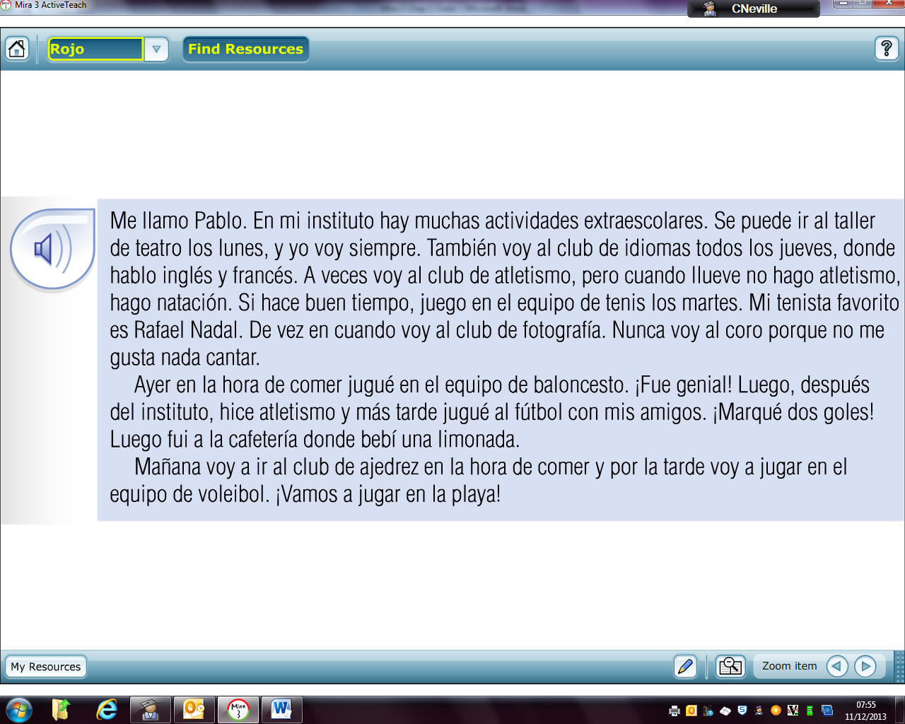

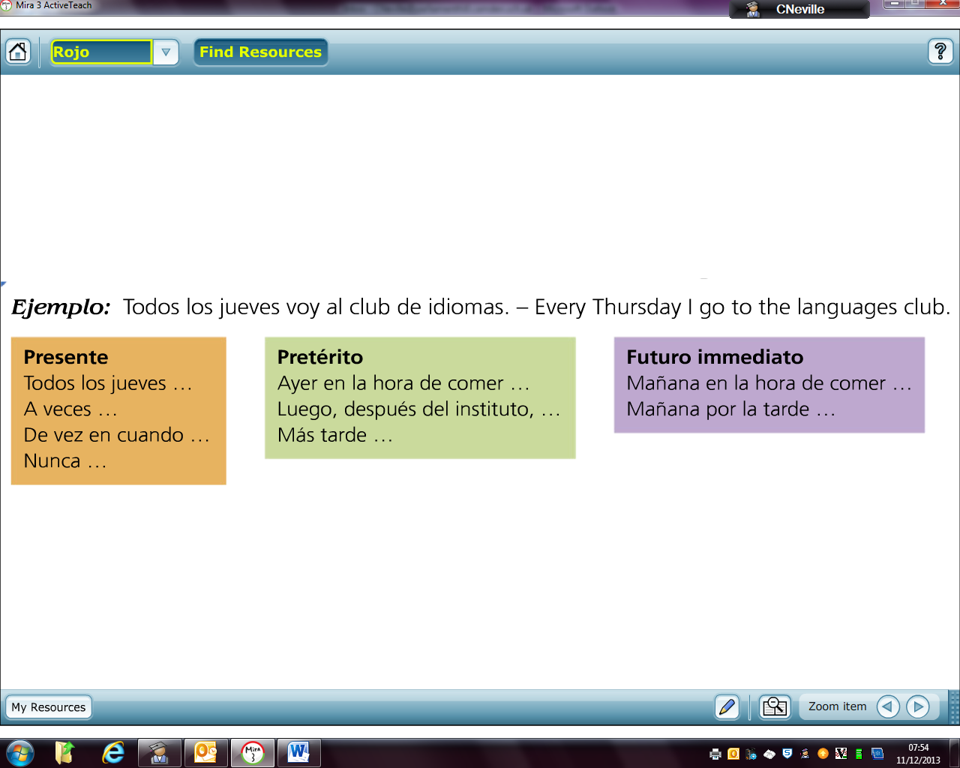

\_\_\_\_\_\_\_\_\_\_\_\_\_\_\_\_\_\_\_\_\_\_\_\_\_\_\_\_\_\_\_\_\_\_\_\_\_\_\_\_\_\_\_\_\_\_\_\_\_\_\_\_\_\_\_\_\_\_\_\_\_\_\_\_\_\_\_\_\_\_\_

\_\_\_\_\_\_\_\_\_\_\_\_\_\_\_\_\_\_\_\_\_\_\_\_\_\_\_\_\_\_\_\_\_\_\_\_\_\_\_\_\_\_\_\_\_\_\_\_\_\_\_\_\_\_\_\_\_\_\_\_\_\_\_\_\_\_\_\_

\_\_\_\_\_\_\_\_\_\_\_\_\_\_\_\_\_\_\_\_\_\_\_\_\_\_\_\_\_\_\_\_\_\_\_\_\_\_\_\_\_\_\_\_\_\_\_\_\_\_\_\_\_\_\_\_\_\_\_\_\_

\_\_\_\_\_\_\_\_\_\_\_\_\_\_\_\_\_\_\_\_\_\_\_\_\_\_\_\_\_\_\_\_\_\_\_\_\_\_\_\_\_\_\_\_\_\_\_\_\_\_\_\_\_\_\_\_\_\_\_\_\_



\_\_\_\_\_\_\_\_\_\_\_\_\_\_\_\_\_\_\_\_\_\_\_\_\_\_\_\_\_\_\_\_\_\_\_\_\_\_\_\_\_\_\_\_\_\_\_\_\_\_\_\_\_\_\_\_\_\_\_\_\_

\_\_\_\_\_\_\_\_\_\_\_\_\_\_\_\_\_\_\_\_\_\_\_\_\_\_\_\_\_\_\_\_\_\_\_\_\_\_\_\_\_\_\_\_\_\_\_\_\_\_\_\_\_\_\_\_\_\_\_\_\_

\_\_\_\_\_\_\_\_\_\_\_\_\_\_\_\_\_\_\_\_\_\_\_\_\_\_\_\_\_\_\_\_\_\_\_\_\_\_\_\_\_\_\_\_\_\_\_\_\_\_\_\_\_\_\_\_\_\_\_\_\_\_\_\_\_\_\_\_\_\_\_\_\_\_



\_\_\_\_\_\_\_\_\_\_\_\_\_\_\_\_\_\_\_\_\_\_\_\_\_\_\_\_\_\_\_\_\_\_\_\_\_\_\_\_\_\_\_\_\_\_\_\_\_\_\_\_\_\_\_\_\_\_\_\_\_

\_\_\_\_\_\_\_\_\_\_\_\_\_\_\_\_\_\_\_\_\_\_\_\_\_\_\_\_\_\_\_\_\_\_\_\_\_\_\_\_\_\_\_\_\_\_\_\_\_\_\_\_\_\_\_\_\_\_\_\_\_\_\_\_

**Corrections, reactions to comments, new vocab etc……**

**Parte 2: Salir con amigos**

1. **¿Quieres ir al cine?**

**1. Empareja (match-up the pictures and places below)**

|  |  |  |  |  |  |  |
| --- | --- | --- | --- | --- | --- | --- |
| **1** |  | **2** |  | **3** |  | **1-**  **2-**  **3-**  **4-**  **5-** |
| **4** |  | **5** |  |  |  |

\_\_\_\_\_\_\_\_\_\_\_\_\_\_\_\_\_\_\_\_\_\_\_\_\_\_\_\_\_\_\_\_\_\_\_\_\_\_\_\_\_\_\_\_\_\_\_\_\_\_\_\_\_\_

|  |  |  |
| --- | --- | --- |
| * 1. El parque de atracciones | * 1. El club de jóvenes | * 1. La bolera |
| * 1. El cine |  | * 1. La pista de hielo |

**2. Lee el diálogo y escribe en español (read the dialogue and find the Spanish translations of the questions in the dialogue, write them down).**

|  |  |
| --- | --- |
| * ¿Diga? * Hola, Ana. Soy Antonio. ¿Quieres ir al cine? * ¿Cuándo? * El domingo. * Vale. ¿A qué hora quedamos? * A las ocho. * ¿Dónde quedamos? * En el parque. * Bueno. * Hasta la vista. * Adiós. | 1. What time shall we meet? \_\_\_\_\_\_\_\_\_\_\_\_\_\_\_\_\_\_\_\_\_\_\_\_\_\_\_\_\_\_\_\_\_\_\_\_\_\_\_\_. 2. Where shall we meet?   \_\_\_\_\_\_\_\_\_\_\_\_\_\_\_\_\_\_\_\_\_\_\_\_\_\_\_\_\_\_\_\_\_\_\_\_\_\_\_\_\_\_.   1. Would you like to go to the cinema?   \_\_\_\_\_\_\_\_\_\_\_\_\_\_\_\_\_\_\_\_\_\_\_\_\_\_\_\_\_\_\_\_\_\_\_\_\_\_\_\_\_\_.   1. When?   \_\_\_\_\_\_\_\_\_\_\_\_\_\_\_\_\_\_\_\_\_\_.   1. Hello?   \_\_\_\_\_\_\_\_\_\_\_\_\_\_\_\_\_\_\_\_\_\_\_ |

**3.Escribe una conversación entre dos personas por SMS/WhatsApp para hacer una cita (write a text/WhatsApp conversation between two people to arrange a meeting – time, date, place, activity)**

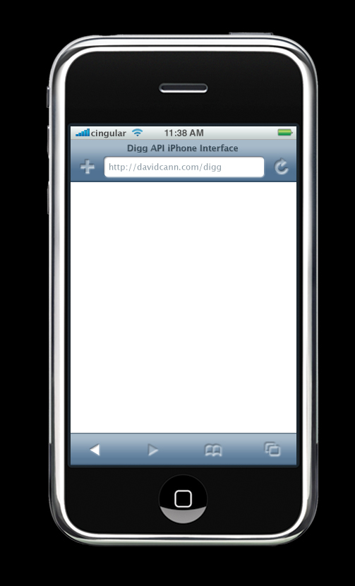

\_\_\_\_\_\_\_\_\_:\_\_\_\_\_\_\_\_\_\_\_\_\_\_\_\_\_\_\_\_\_\_\_\_\_\_\_\_\_\_\_\_\_\_\_\_\_\_\_

\_\_\_\_\_\_\_\_\_:\_\_\_\_\_\_\_\_\_\_\_\_\_\_\_\_\_\_\_\_\_\_\_\_\_\_\_\_\_\_\_\_\_\_\_\_\_

\_\_\_\_\_\_\_\_\_:\_\_\_\_\_\_\_\_\_\_\_\_\_\_\_\_\_\_\_\_\_\_\_\_\_\_\_\_\_\_\_\_\_\_\_\_\_\_\_

\_\_\_\_\_\_\_\_\_:\_\_\_\_\_\_\_\_\_\_\_\_\_\_\_\_\_\_\_\_\_\_\_\_\_\_\_\_\_\_\_\_\_\_\_\_\_

\_\_\_\_\_\_\_\_\_:\_\_\_\_\_\_\_\_\_\_\_\_\_\_\_\_\_\_\_\_\_\_\_\_\_\_\_\_\_\_\_\_\_\_\_\_\_\_\_

\_\_\_\_\_\_\_\_\_:\_\_\_\_\_\_\_\_\_\_\_\_\_\_\_\_\_\_\_\_\_\_\_\_\_\_\_\_\_\_\_\_\_\_\_\_\_

\_\_\_\_\_\_\_\_\_:\_\_\_\_\_\_\_\_\_\_\_\_\_\_\_\_\_\_\_\_\_\_\_\_\_\_\_\_\_\_\_\_\_\_\_\_\_\_\_

\_\_\_\_\_\_\_\_\_:\_\_\_\_\_\_\_\_\_\_\_\_\_\_\_\_\_\_\_\_\_\_\_\_\_\_\_\_\_\_\_\_\_\_\_\_\_

\_\_\_\_\_\_\_\_\_:\_\_\_\_\_\_\_\_\_\_\_\_\_\_\_\_\_\_\_\_\_\_\_\_\_\_\_\_\_\_\_\_\_\_\_\_\_\_\_

\_\_\_\_\_\_\_\_\_:\_\_\_\_\_\_\_\_\_\_\_\_\_\_\_\_\_\_\_\_\_\_\_\_\_\_\_\_\_\_\_\_\_\_\_\_\_

\_\_\_\_\_\_\_\_\_:\_\_\_\_\_\_\_\_\_\_\_\_\_\_\_\_\_\_\_\_\_\_\_\_\_\_\_\_\_\_\_\_\_\_\_\_\_\_\_

\_\_\_\_\_\_\_\_\_:\_\_\_\_\_\_\_\_\_\_\_\_\_\_\_\_\_\_\_\_\_\_\_\_\_\_\_\_\_\_\_\_\_\_\_\_\_

\_\_\_\_\_\_\_\_\_:\_\_\_\_\_\_\_\_\_\_\_\_\_\_\_\_\_\_\_\_\_\_\_\_\_\_\_\_\_\_\_\_\_\_\_\_\_\_\_

\_\_\_\_\_\_\_\_\_:\_\_\_\_\_\_\_\_\_\_\_\_\_\_\_\_\_\_\_\_\_\_\_\_\_\_\_\_\_\_\_\_\_\_\_\_\_

1. **¿Qué tipo de películas te gustan?**
2. **Empareja y completa (match-up and complete)**

|  |  |
| --- | --- |
| 1. N\_\_ m\_\_ g\_\_st\_\_n l\_\_s p\_\_líc\_\_l\_\_s d\_\_ \_\_cc\_\_ón | * 1. I prefer comedies.   2. I like animated films.   3. I prefer romantic films.   4. I don’t like action films.   5. I don’t like science fiction films.   6. I like horror films. |
| 1. M\_\_ g\_\_st\_\_n l\_\_s p\_\_líc\_\_l\_\_s d\_\_ d\_\_b\_\_j\_\_s \_\_n\_\_m\_\_d\_\_s |
| 1. Pr\_\_f\_\_ \_\_r\_\_ l\_\_s p\_\_líc\_\_l\_\_s cóm\_\_c\_\_s |
| 1. M\_\_ g\_\_st\_\_n l\_\_s p\_\_líc\_\_l\_\_s d\_\_ t\_\_rr\_\_r |
| 1. Pr\_\_f\_\_ \_\_r\_\_ l\_\_s p\_\_líc\_\_l\_\_s r\_\_mánt\_\_c\_\_s |
| 1. N\_\_ m\_\_ g\_\_st\_\_n l\_\_s p\_\_líc\_\_l\_\_s d\_\_ c\_\_ \_\_nc\_\_ \_\_-f\_\_cc\_\_ón |

|  |  |  |  |  |  |  |  |  |  |  |  |
| --- | --- | --- | --- | --- | --- | --- | --- | --- | --- | --- | --- |
| 1. | OO | 2. | OO | 3. | OO | 4. | OO | 5. | OO | 6. | OO |

**Corrections, reactions to comments, new vocab etc……**

**2. Lee y contesta las preguntas (read and answer the questions in English)**

|  |  |
| --- | --- |
| ¡Hola Antonio!  ¿Qué tipo de películas prefieres? A mí me gustan las películas de acción porque son emocionantes. También me gustan las películas de ciencia-ficción porque son interesantes. Mi película favorita es Terminator II. No me gustan las películas románticas porque son aburridas. Prefiero las películas cómicas porque son divertidas.  Ana. | 1. What type of films does Ana like?   \_\_\_\_\_\_\_\_\_\_\_\_\_\_\_\_\_\_\_\_\_\_\_\_\_\_\_\_\_\_\_\_\_\_\_   1. What type of films does she think are exciting?   \_\_\_\_\_\_\_\_\_\_\_\_\_\_\_\_\_\_\_\_\_\_\_\_\_\_\_\_\_\_\_\_\_\_\_   1. What is her favourite film?   \_\_\_\_\_\_\_\_\_\_\_\_\_\_\_\_\_\_\_\_\_\_\_\_\_\_\_\_\_\_\_\_\_\_\_   1. What type of films doesn’t she like?   \_\_\_\_\_\_\_\_\_\_\_\_\_\_\_\_\_\_\_\_\_\_\_\_\_\_\_\_\_\_\_\_\_\_\_   1. What types of films does she prefer?   \_\_\_\_\_\_\_\_\_\_\_\_\_\_\_\_\_\_\_\_\_\_\_\_\_\_\_\_\_\_\_\_\_\_\_   1. Why does she prefer them?   \_\_\_\_\_\_\_\_\_\_\_\_\_\_\_\_\_\_\_\_\_\_\_\_\_\_\_\_\_\_\_\_\_\_\_ |

**Corrections, reactions to comments, new vocab etc……**

**C) Dos entradas, por favor.**

**1. Pon las frases en orden y escribe un diálogo (put the sentences in order and write a dialogue).**

|  |  |
| --- | --- |
| * Son once euros. | * \_\_\_\_\_\_\_\_\_\_\_\_\_\_\_\_\_\_\_\_\_\_ |
| * Para la sesión de las diez y media. | * \_\_\_\_\_\_\_\_\_\_\_\_\_\_\_\_\_\_\_\_\_\_ |
| * Para *El Señor de los Anillos*. | * \_\_\_\_\_\_\_\_\_\_\_\_\_\_\_\_\_\_\_\_\_\_ |
| * ¿Cuánto es? | * \_\_\_\_\_\_\_\_\_\_\_\_\_\_\_\_\_\_\_\_\_\_ |
| * Tres entradas, por favor. | * \_\_\_\_\_\_\_\_\_\_\_\_\_\_\_\_\_\_\_\_\_\_ |
| * Aquí tiene. | * \_\_\_\_\_\_\_\_\_\_\_\_\_\_\_\_\_\_\_\_\_\_ |
| * ¿Para qué sesión? | * \_\_\_\_\_\_\_\_\_\_\_\_\_\_\_\_\_\_\_\_\_\_ |
| * ¿Para qué película? | * \_\_\_\_\_\_\_\_\_\_\_\_\_\_\_\_\_\_\_\_\_\_ |

**2. Escribe el título de una peícula apta para las siguientes personas (write the Spanish title of a film that you would recommend for the following sets of people).**

|  |  |  |
| --- | --- | --- |
| 1. | Dos amigos de 25 años |  |
| 2. | Unos amigos de 18 años |  |
| 3. | Una familia con una niña de 4 años |  |
| 4. | Unos novios de 30 años. |  |
| 5. | Un grupo de jóvenes de 13 años. |  |

**Corrections, reactions to comments, new vocab etc……**

**Parte 3: Las vacaciones**

**A) ¡Es genial!**

**1. Empareja (match-up and invent pictures for the two remaining ones).**

|  |  |  |  |  |  |
| --- | --- | --- | --- | --- | --- |
|  | Estoy en el Museo del Prado. |  | oo |  |  |
|  | El parque Zoológico es fenomenal. |  |  |  |
|  | Estamos en el sur de España. |  |  |  |
|  | Hace sol y calor. |  |  |  |
|  | Es interesante porque visitamos muchos monumentos. |  |  |  |
|  | Estoy con mis amigos y jugamos al fútbol en el parque. |  |  |  |

|  |  |  |  |  |  |
| --- | --- | --- | --- | --- | --- |
| **a.** |  | **c.** |  | **e.** |  |
| **b.** |  | **d.** |  | **f.** |  |

**2.Escribe una tarjeta postal (You are on holiday. use the sentences in the Grammar and Vocabulary sections at the beginning of this booklet to write a postcard).**

|  |
| --- |
| Querido \_\_\_\_\_\_\_\_\_\_:  Estoy de vacaciones en \_\_\_\_\_\_\_\_\_\_\_\_\_\_\_\_\_\_\_\_\_\_\_\_\_\_\_\_\_\_  Estoy con \_\_\_\_\_\_\_\_\_\_\_\_\_\_\_\_\_\_\_\_\_\_\_\_\_\_\_\_\_\_\_\_\_\_\_\_\_\_\_\_  Aquí hace \_\_\_\_\_\_\_\_\_\_\_\_\_\_\_\_\_\_\_\_\_\_\_\_\_\_\_\_\_\_\_\_\_\_\_\_\_\_\_\_  Es \_\_\_\_\_\_\_\_\_\_\_\_\_\_\_\_\_\_\_\_\_\_\_\_\_\_\_\_\_\_\_\_\_\_\_\_\_\_\_\_\_\_\_\_\_\_  \_\_\_\_\_\_\_\_\_\_\_\_\_\_\_ |

**B) ¿Qué hiciste el sábado?**

**1. Escribe las frases en el cuadro (separate the words and write out the sentences in the grid)**

**viunpartidoentremadridyvalenciabebíunanaranjadafuiencoche**

**comípatatasfritasyhamburguesaviamiamigosalídecasaalascincoymedia**

|  |
| --- |
|  |
|  |
|  |
|  |
|  |
|  |

**2. Pon las palabras en el orden correcto y traduce al inglés (put the words in the write order and translate into English, then complete the crossword)**

|  |  |
| --- | --- |
|  | Across  3. we ate  6. I drank  7. I saw  10. You (pl) went out  Down  1. They did  2. I ate  3. You ate  4. I went out  5. We saw  8. I went  9. I did |

**C) Detalles sobre las vacaciones**

1. **Mira el mapa y contesta a las preguntas (look at the map and answer the questions)**

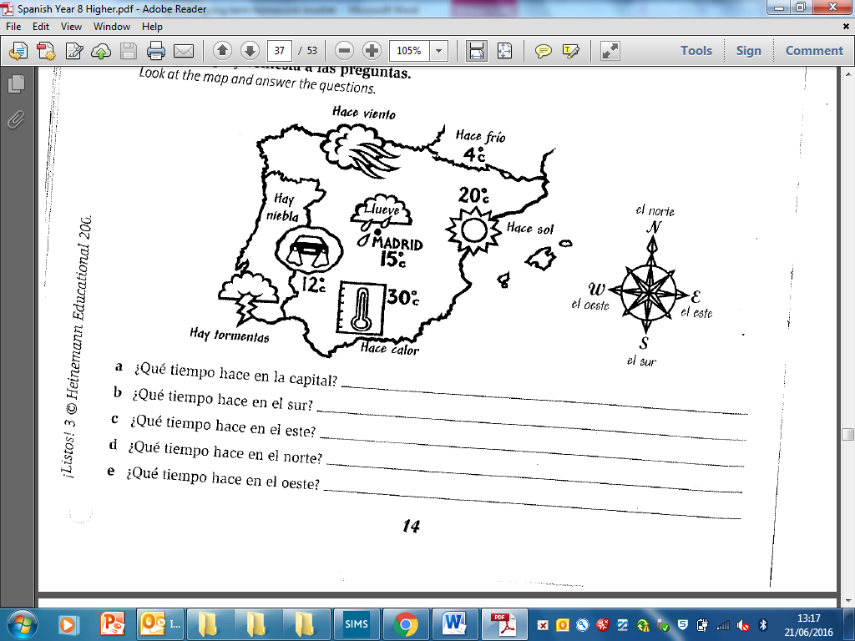

1. **Describe el tiempo que hace en Londres (describe the weather in London according to the seasons for a Spanish tourist).**

En primavera \_\_\_\_\_\_\_\_\_\_\_\_\_\_\_\_\_\_\_\_\_\_\_\_\_\_\_\_\_\_\_\_\_\_\_\_\_\_\_\_\_\_\_\_\_\_\_\_\_

\_\_\_\_\_\_\_\_\_\_\_\_\_\_\_\_\_\_\_\_\_\_\_\_\_\_\_\_\_\_\_\_\_\_\_\_\_\_\_\_\_\_\_\_\_\_\_\_\_\_\_\_\_\_\_\_\_\_ .

En verano \_\_\_\_\_\_\_\_\_\_\_\_\_\_\_\_\_\_\_\_\_\_\_\_\_\_\_\_\_\_\_\_\_\_\_\_\_\_\_\_\_\_\_\_\_\_\_\_\_\_\_

\_\_\_\_\_\_\_\_\_\_\_\_\_\_\_\_\_\_\_\_\_\_\_\_\_\_\_\_\_\_\_\_\_\_\_\_\_\_\_\_\_\_\_\_\_\_\_\_\_\_\_\_\_\_\_\_\_\_ .

En otoño \_\_\_\_\_\_\_\_\_\_\_\_\_\_\_\_\_\_\_\_\_\_\_\_\_\_\_\_\_\_\_\_\_\_\_\_\_\_\_\_\_\_\_\_\_\_\_\_\_\_\_\_

\_\_\_\_\_\_\_\_\_\_\_\_\_\_\_\_\_\_\_\_\_\_\_\_\_\_\_\_\_\_\_\_\_\_\_\_\_\_\_\_\_\_\_\_\_\_\_\_\_\_\_\_\_\_\_\_\_\_ .

En invierno \_\_\_\_\_\_\_\_\_\_\_\_\_\_\_\_\_\_\_\_\_\_\_\_\_\_\_\_\_\_\_\_\_\_\_\_\_\_\_\_\_\_\_\_\_\_\_\_\_\_\_

\_\_\_\_\_\_\_\_\_\_\_\_\_\_\_\_\_\_\_\_\_\_\_\_\_\_\_\_\_\_\_\_\_\_\_\_\_\_\_\_\_\_\_\_\_\_\_\_\_\_\_\_\_\_\_\_\_\_ .

**Corrections, reactions to comments, new vocab etc……**

1. **Empareja (match up the activities)**

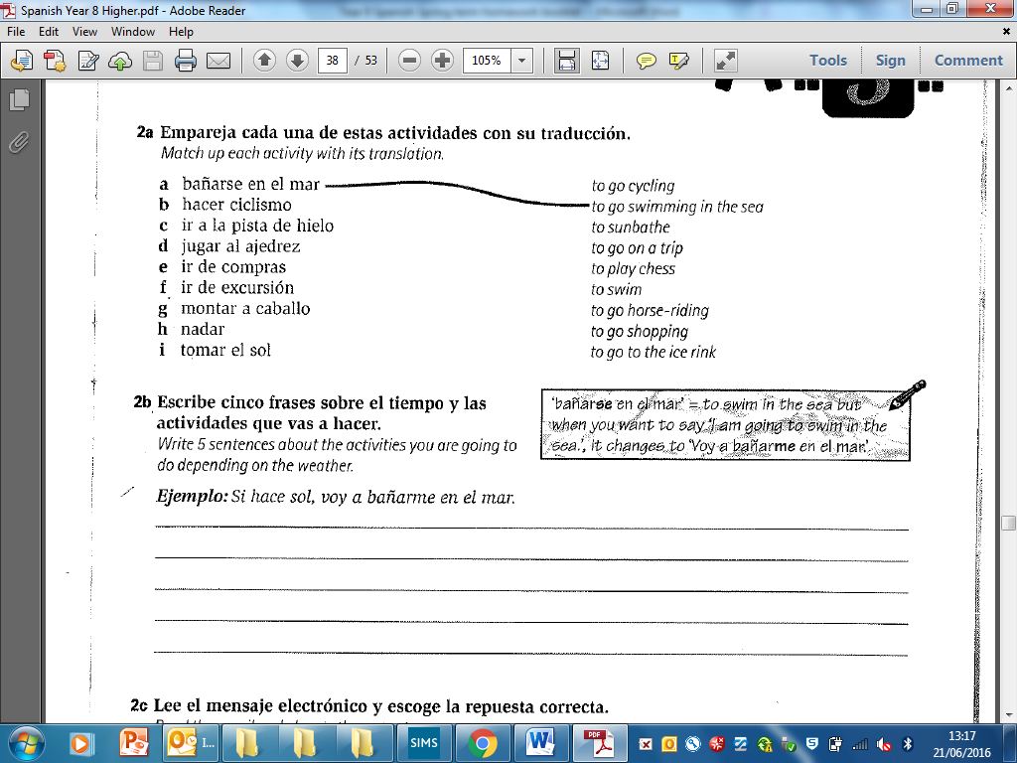

1. **Escribe cinco frases sobre el tiempo y las actividades que vas a hacer (write five sentences about the activities you are going to do depensing on the weather).**



**Corrections, reactions to comments, new vocab etc……**

1. **Lee el mensaje electrónico y escoje la respuesta correcta (read the email and select the correct answer).**

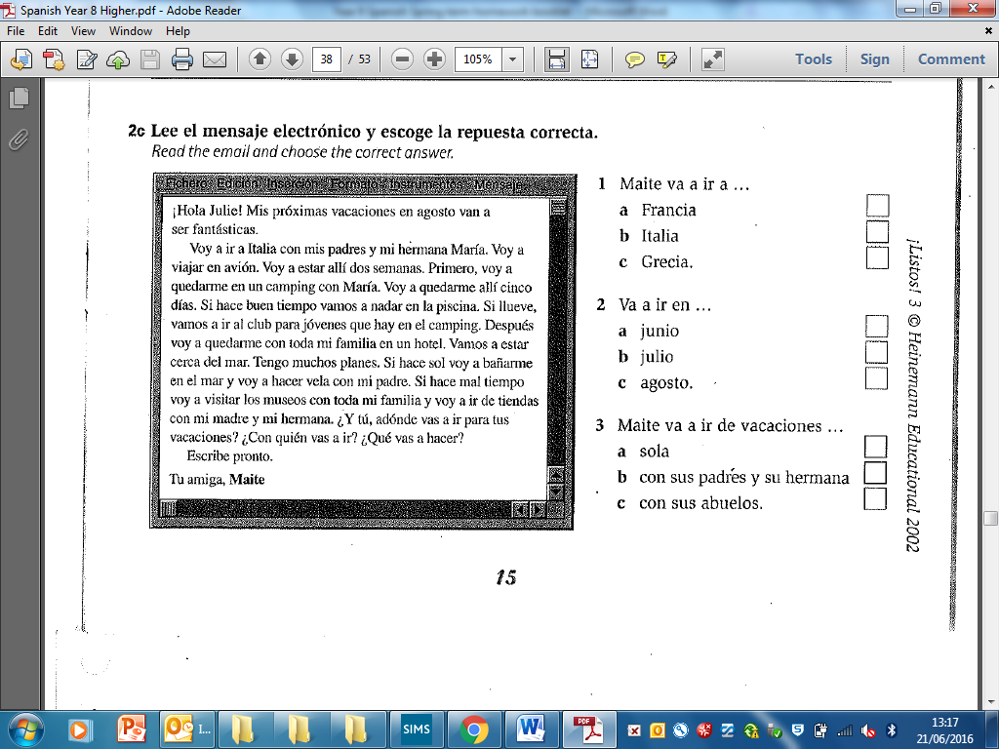



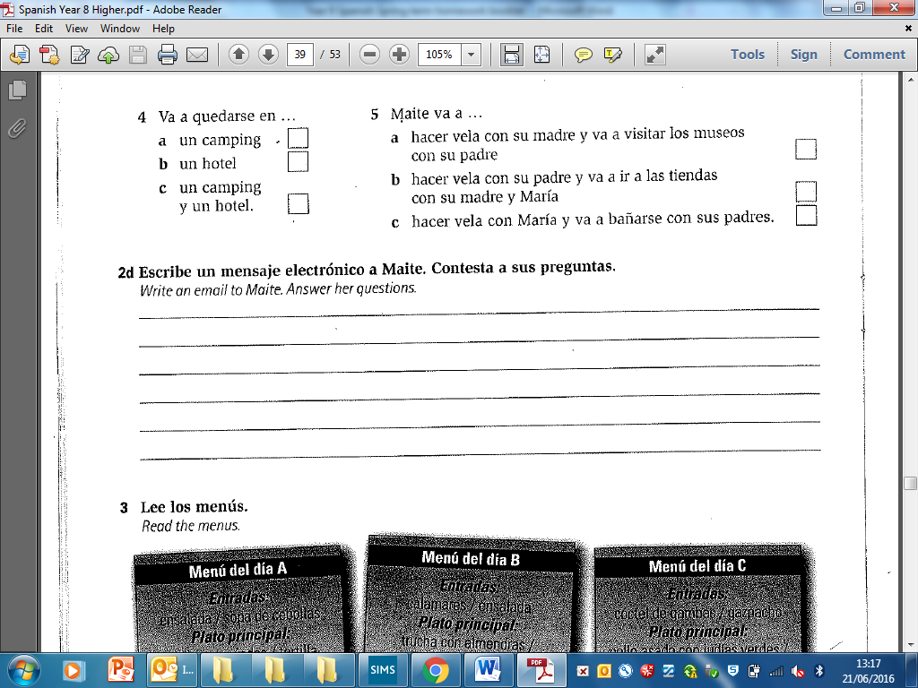

1. **Escribe un mensaje electrónico a Maite. Contesta a sus preguntas (Write an email to Maite answering her questions)**

\_\_\_\_\_\_\_\_\_\_\_\_\_\_\_\_\_\_\_\_\_\_\_\_\_\_\_\_\_\_\_\_\_\_\_\_\_\_\_\_\_\_\_\_\_\_\_\_\_\_\_\_\_\_\_\_\_\_\_\_\_\_\_\_\_\_\_\_\_\_\_\_\_\_\_\_\_\_\_\_\_\_\_\_\_\_\_\_\_\_\_\_\_\_\_\_\_\_\_\_\_\_\_\_\_\_\_\_\_\_\_\_\_\_\_\_\_\_\_\_\_\_\_\_\_\_\_\_\_\_\_\_\_\_\_\_\_\_\_\_\_\_\_\_\_\_\_\_\_\_\_\_\_\_\_\_\_\_\_\_\_\_\_\_\_\_\_\_\_\_\_\_\_\_\_\_\_\_\_\_\_\_\_\_\_\_\_\_\_\_\_\_\_\_\_\_\_\_\_\_\_\_\_\_\_\_\_\_\_\_\_\_\_\_\_\_\_\_\_\_\_\_\_\_\_\_\_\_\_\_\_\_\_\_\_\_\_\_\_\_\_\_\_\_\_\_\_\_\_\_\_\_\_\_\_\_\_\_\_\_\_\_\_\_\_\_\_\_\_\_\_\_\_\_\_\_\_\_\_\_\_\_\_\_\_\_\_\_\_\_\_\_\_\_\_\_\_\_\_\_\_\_\_\_\_\_\_\_\_\_\_\_\_\_\_\_\_\_\_\_\_\_\_\_\_\_\_\_\_\_\_\_\_\_\_\_\_\_\_\_\_\_\_\_\_\_\_\_\_\_\_\_\_\_\_\_\_\_\_\_\_\_\_\_\_\_\_\_\_\_\_\_\_\_\_\_\_\_\_\_\_\_\_\_\_\_\_\_\_\_\_\_\_\_\_\_\_\_\_\_\_\_\_\_\_\_\_\_\_\_\_\_\_\_\_\_\_\_\_\_\_\_\_\_\_\_\_\_\_\_\_\_\_\_\_\_\_\_\_\_\_\_\_\_\_\_\_\_\_\_\_\_\_\_\_\_\_\_\_\_\_\_\_\_\_\_\_\_\_\_\_\_\_\_\_\_\_\_\_\_\_\_\_\_\_\_\_\_\_\_\_\_\_\_\_\_\_\_\_\_\_\_\_\_\_\_\_\_\_\_\_\_\_\_\_\_

1. **Lee los menus y escribe lo que comieron (read the menus and write what they ate in Spanish)**

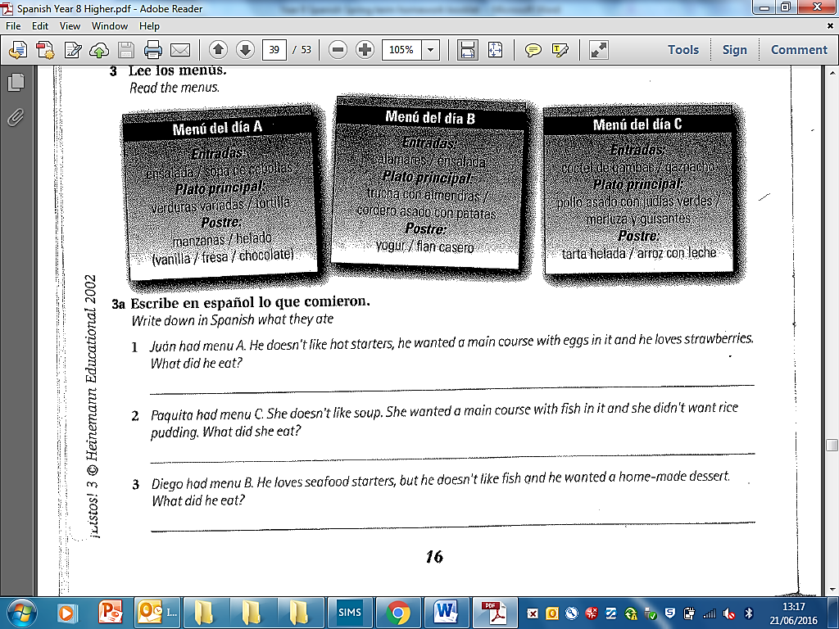

**Corrections, reactions to comments, new vocab etc……**

**D) De fiesta y de vacaciones**

1. **Match-up the words**

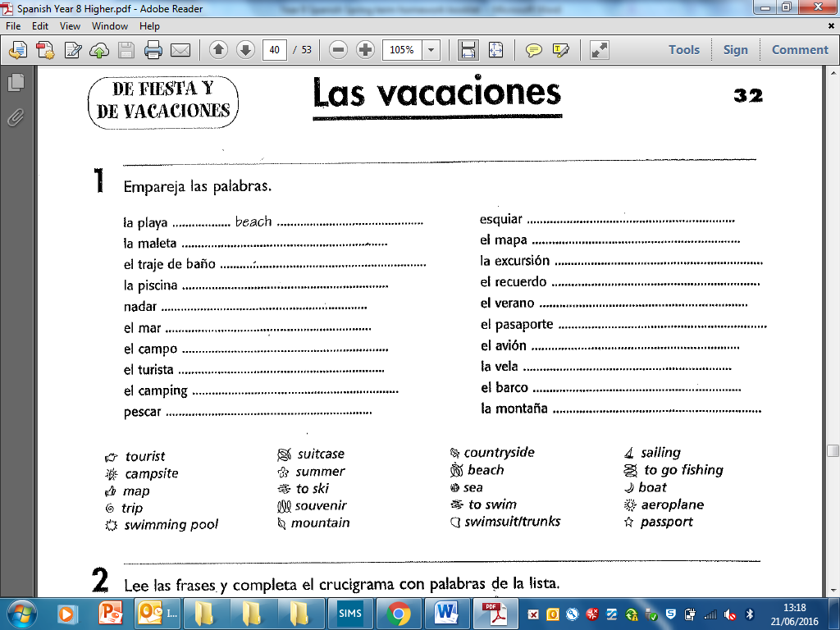

1. **Lee las frases y completa el crucigrama con palabras de la lista (read the sentences and complete the crossword with words from the list)** 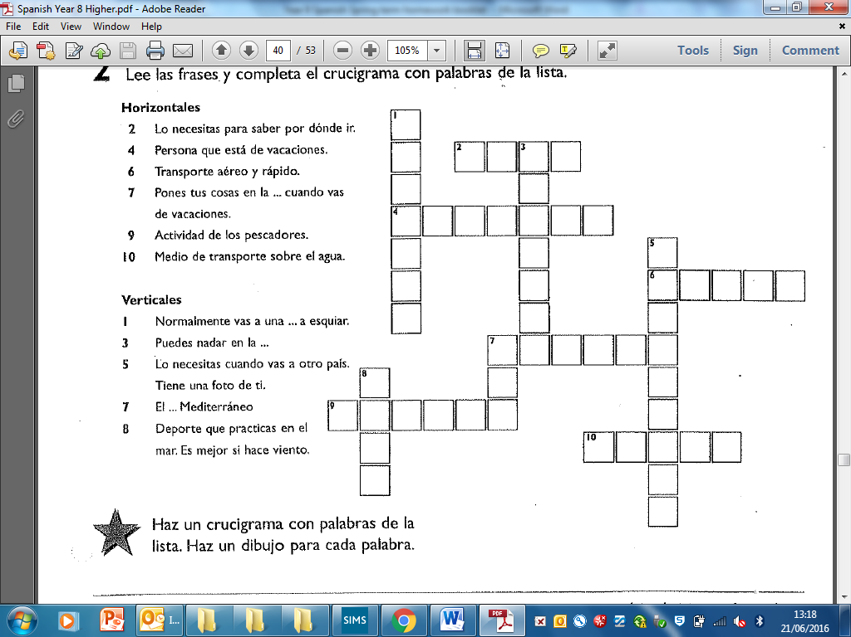
2. **Haz un crucigrama con palabras de la lista y haz un dibujo para cada palabra (create a crossword with the words from the match-up list and make a picture for each word)**

**4. Lee las tres descripciones de los lugares de veraneo y contesta a las preguntas (read the three descriptions of the holidays destinations and answer the questions).**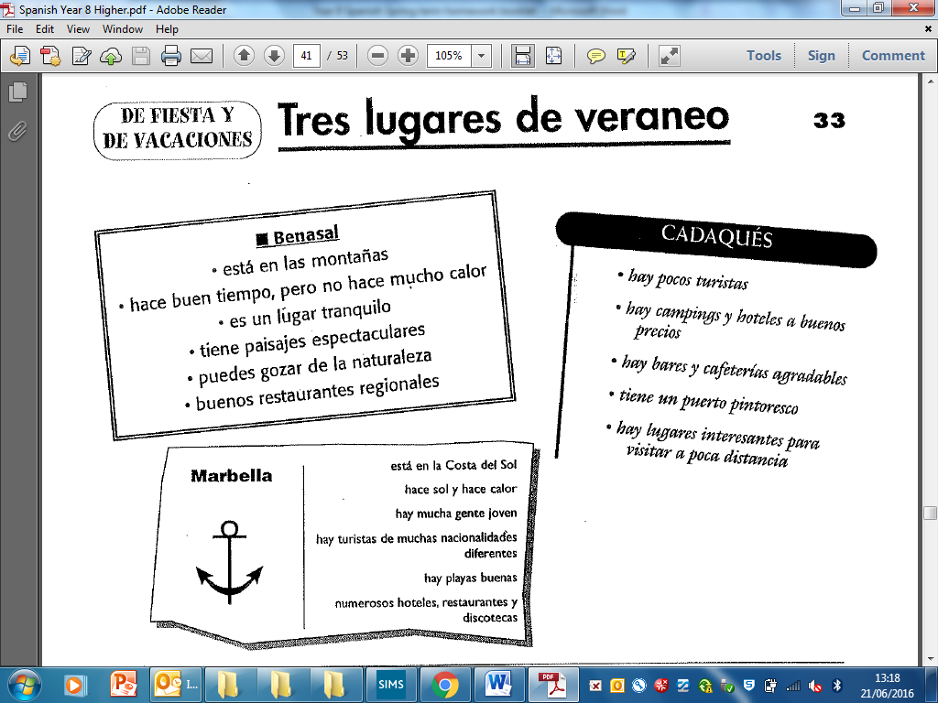

**i. Busca las frases que describen (find the phrases that describe):**

1. **el tiempo \_\_\_\_\_\_\_\_\_\_\_\_\_\_\_\_\_\_\_\_\_\_\_\_\_\_\_\_\_\_\_\_\_\_\_\_\_\_\_\_\_\_\_\_\_\_\_**

**\_\_\_\_\_\_\_\_\_\_\_\_\_\_\_\_\_\_\_\_\_\_\_\_\_\_\_\_\_\_\_\_\_\_\_\_\_\_\_\_\_\_\_\_\_\_\_\_\_\_\_\_\_\_\_**

1. **la gente\_\_\_\_\_\_\_\_\_\_\_\_\_\_\_\_\_\_\_\_\_\_\_\_\_\_\_\_\_\_\_\_\_\_\_\_\_\_\_\_\_\_\_\_\_\_\_\_**

**\_\_\_\_\_\_\_\_\_\_\_\_\_\_\_\_\_\_\_\_\_\_\_\_\_\_\_\_\_\_\_\_\_\_\_\_\_\_\_\_\_\_\_\_\_\_\_\_\_\_\_\_\_\_\_**

1. **los pasatiempos\_\_\_\_\_\_\_\_\_\_\_\_\_\_\_\_\_\_\_\_\_\_\_\_\_\_\_\_\_\_\_\_\_\_\_\_\_\_\_\_\_\_\_**

**\_\_\_\_\_\_\_\_\_\_\_\_\_\_\_\_\_\_\_\_\_\_\_\_\_\_\_\_\_\_\_\_\_\_\_\_\_\_\_\_\_\_\_\_\_\_\_\_\_\_\_\_\_\_\_**

**ii. Elige el lugar apropriado para cada persona (pick the best place for each person).**

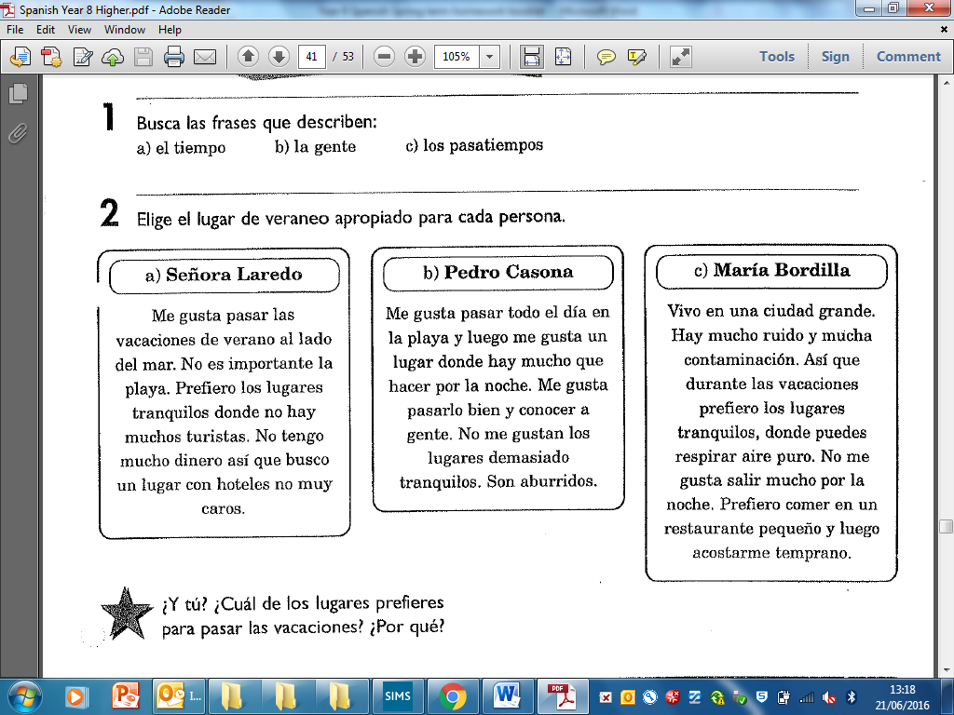

**\_\_\_\_\_\_\_\_\_\_\_\_\_\_\_\_\_ \_\_\_\_\_\_\_\_\_\_\_\_\_\_ \_\_\_\_\_\_\_\_\_\_\_\_\_\_\_\_\_\_\_\_**

**iii. ¿Y tú? ¿Cuál de los lugares prefieres y por qué?**

**\_\_\_\_\_\_\_\_\_\_\_\_\_\_\_\_\_\_\_\_\_\_\_\_\_\_\_\_\_\_\_\_\_\_\_\_\_\_\_\_\_\_\_\_\_\_\_\_\_\_\_\_\_\_\_\_\_\_\_\_\_\_\_\_\_\_\_\_\_\_\_\_\_\_\_\_\_\_\_\_\_\_\_\_\_\_\_\_\_\_\_\_\_\_\_\_\_\_\_\_\_\_\_\_\_\_\_\_\_\_\_\_\_\_\_\_\_\_\_\_\_\_\_\_\_\_\_\_\_\_\_\_\_\_\_\_\_\_\_\_\_\_\_\_\_\_\_\_\_\_\_\_\_\_\_\_\_\_\_\_\_\_\_\_\_\_\_\_\_\_\_\_\_\_\_\_\_\_\_\_\_\_\_\_\_\_\_\_\_\_\_\_\_\_\_\_\_\_\_\_\_\_\_\_\_\_\_\_\_\_\_\_\_\_\_\_\_\_\_\_**

1. **Lee esta carta sobre las vacaciones de Silvia y contesta a las preguntas (read this letter about Silvia’s holidays and answer the questions).**

El fin de semana pasado fui a Madrid. Fui en autobús y llegué a eso de las cinco de la tarde.

Me alojé en un albergue juvenil en el centro de

la ciudad.

Al día siguiente me levanté muy temprano y fui a

dar un paseo por la ciudad. Visité el Palacio Real

y el Museo del Prado. Vi la Puerta de Alcalá,

la Cibeles y el Retiro. Por la tarde fui al

Rastro y a mis hermanos les compré

muchas cosas chulas: camisetas, CD,

libros… Luego volví al albergue, cené en la cafetería y me acosté.

¡Qué bonito es Madrid!

Me encantó. ¡Me lo pasé bomba!

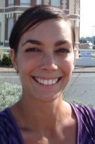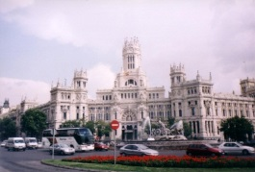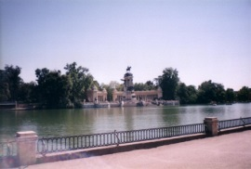

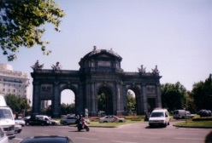

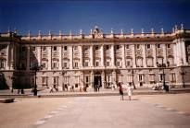

**Silvia**

**Part 1:** *Find all the verbs in the preterite tense and put a box around them. Don’t count the same one twice (there are 11 in total***Part 2:** *What are the underlined places in the text? Write at least 3 short details about them in SPANISH in the grid below.*

|  |  |
| --- | --- |
| **Madrid** | **Madrid está en el centro de España** |
|  |  |
|  |  |
|  |  |
|  |  |
|  |  |
|  |  |

1. **Mi viaje a Barcelona – copia los infinitivos y traduce al inglés (copy out the infinitives from the box below and translate them into English like the example).**

**los infinitivos**

viajar, beber, comprar, visitar, salir, coger,

nadar, desayunar, preparar, comer, ir\*, montar.

C:\Users\cneville.PARLIAMENT.000\AppData\Local\Microsoft\Windows\Temporary Internet Files\Content.IE5\UR3NSYQ4\MC900231161[1].wmf

|  |  |
| --- | --- |
| **Infinitivo en español** | **Infinitivo en inglés** |
| viajar | to travel |
|  |  |
|  |  |
|  |  |
|  |  |
|  |  |
|  |  |
|  |  |
|  |  |
|  |  |
|  |  |
|  |  |

**Corrections, reactions to comments, new vocab etc……**

1. **Haz frases (make sentences using the pictures and by conjugating the verbs from the table in exercise 5 to explain what the different people do on holiday)**

|  |  |  |
| --- | --- | --- |
| 16_1 | **I** | **\_\_\_\_\_\_\_\_\_\_\_\_\_\_\_\_\_\_\_\_\_\_\_\_\_\_\_\_\_\_\_\_\_\_\_\_\_\_\_\_\_\_\_\_\_\_** |
| CIMG0066 | **You** | **\_\_\_\_\_\_\_\_\_\_\_\_\_\_\_\_\_\_\_\_\_\_\_\_\_\_\_\_\_\_\_\_\_\_\_\_\_\_\_\_\_\_\_\_\_\_** |
| ramblasreduced | **He/She/It** | **\_\_\_\_\_\_\_\_\_\_\_\_\_\_\_\_\_\_\_\_\_\_\_\_\_\_\_\_\_\_\_\_\_\_\_\_\_\_\_\_\_\_\_\_\_\_** |
| DSCN0915 | **We** | **\_\_\_\_\_\_\_\_\_\_\_\_\_\_\_\_\_\_\_\_\_\_\_\_\_\_\_\_\_\_\_\_\_\_\_\_\_\_\_\_\_\_\_\_\_\_** |
| CIMG0036 | **You** | **\_\_\_\_\_\_\_\_\_\_\_\_\_\_\_\_\_\_\_\_\_\_\_\_\_\_\_\_\_\_\_\_\_\_\_\_\_\_\_\_\_\_\_\_\_\_** |
| CIMG0100 | **They** | **\_\_\_\_\_\_\_\_\_\_\_\_\_\_\_\_\_\_\_\_\_\_\_\_\_\_\_\_\_\_\_\_\_\_\_\_\_\_\_\_\_\_\_\_\_\_** |
| CIMG0084 | **I** | **\_\_\_\_\_\_\_\_\_\_\_\_\_\_\_\_\_\_\_\_\_\_\_\_\_\_\_\_\_\_\_\_\_\_\_\_\_\_\_\_\_\_\_\_\_\_** |
| RECEPTION | **You** | **\_\_\_\_\_\_\_\_\_\_\_\_\_\_\_\_\_\_\_\_\_\_\_\_\_\_\_\_\_\_\_\_\_\_\_\_\_\_\_\_\_\_\_\_\_\_** |
| dormitorio1 | **He/she/it** | **\_\_\_\_\_\_\_\_\_\_\_\_\_\_\_\_\_\_\_\_\_\_\_\_\_\_\_\_\_\_\_\_\_\_\_\_\_\_\_\_\_\_\_\_\_\_** |
| CIMG0112 | **We** | **\_\_\_\_\_\_\_\_\_\_\_\_\_\_\_\_\_\_\_\_\_\_\_\_\_\_\_\_\_\_\_\_\_\_\_\_\_\_\_\_\_\_\_\_\_\_** |

1. **Utiliza los infinitivos y las imágenes para describir lo que hizo Juan cuando fue a Barcelona. (Use the infinitives below and the pictures to write about what Juanjo did when he went to Barcelona)**

**los infinitivos**

viajar, beber, comprar, visitar, salir, coger, nadar, desayunar, preparar, comer, ir\*, montar.

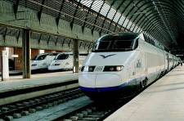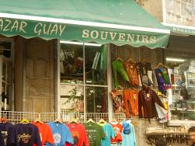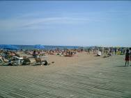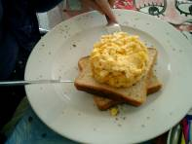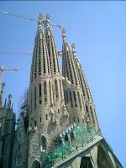

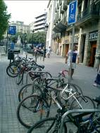

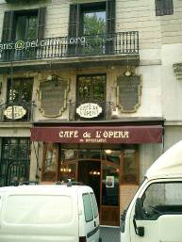

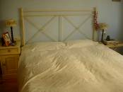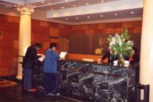

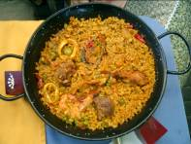

…………………………………………………………………………………………………………………………………………..…………………………………………………………………………………………………………………………………………..…………………………………………………………………………………………………………………………………………..…………………………………………………………………………………………………………………………………………..…………………………………………………………………………………………………………………………………………..…………………………………………………………………………………………………………………………………………..…………………………………………………………………………………………………………………………………………..…………………………………………………………………………………………………………………………………………..…………………………………………………………………………………………………………………………………………..…………………………………………………………………………………………………………………………………………..………………………………………………………………………………

1. **En mi barrio**
2. **Escribe las ciudades y regiones principales de España (write the main city and regions of Spain and draw a star next to the place you would most like to visit).**

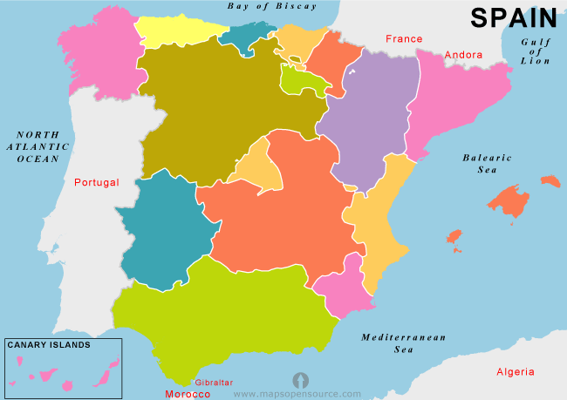

**Corrections, reactions to comments, new vocab etc……**

1. **a) Lee el texto y contesta a las preguntas en castellano o en inglés (read the text and answer the questions in Spanish or in English)**

Hola, me llamo Paola y te hablo de mi barrio en Madrid. Mi barrio es más bonito que Camden y se puede hacer muchas cosas interesantes durante el día.

A las ocho de la mañana, se puede partinar en el parque porque hay más parques en mi barrio que en Camden. Después se puede tomar un café y comer en un café. Los cafes de mi barrio son más grandes que los cafes de Camden. Yo como con Fred siempre.

A las diez de la mañana, se puede ir en bici por todo el barrio porque hay menos tráfico. Se puede ver los edificios fantásticos, el ayuntamiento y la estacion de metro al lado del parque. Yo voy en bici con Alejandra todos los días y pienso que mi barrio es más interesante que Camden porque hay menos tráfico.

Durante la hora de comer, se puede nadar en la piscina al lado de mi casa porque se abre a las doce de la tarde. También se puede hacer un picnic en las plazas de mi barrio porque hay mas plazas en mi barrio que en el centro de Londres y hay menos punkis.

Por la noche se puede bailar en las discotecas porque hay muchas discotecas grandes en mi barrio. Lo bueno de mi barrio es que mis amigas Lola, Julia y Carolina viven al lado y voy con ellas. También se puede ver el teatro pero no se puede cantar.

¿Y tú?

1. ¿Qué hace Paola a las ocho ?

\_\_\_\_\_\_\_\_\_\_\_\_\_\_\_\_\_\_\_\_\_\_\_\_\_\_\_\_\_\_\_\_\_\_\_\_\_\_\_\_\_\_\_\_\_\_\_\_\_\_\_\_\_\_\_

1. ¿Con quién toma un café ?

\_\_\_\_\_\_\_\_\_\_\_\_\_\_\_\_\_\_\_\_\_\_\_\_\_\_\_\_\_\_\_\_\_\_\_\_\_\_\_\_\_\_\_\_\_\_\_\_\_\_\_\_\_\_\_

1. ¿Cómo son los cafés de Camden ?

\_\_\_\_\_\_\_\_\_\_\_\_\_\_\_\_\_\_\_\_\_\_\_\_\_\_\_\_\_\_\_\_\_\_\_\_\_\_\_\_\_\_\_\_\_\_\_\_\_\_\_\_\_\_\_

1. ¿Qué se puede hacer a las diez ?

\_\_\_\_\_\_\_\_\_\_\_\_\_\_\_\_\_\_\_\_\_\_\_\_\_\_\_\_\_\_\_\_\_\_\_\_\_\_\_\_\_\_\_\_\_\_\_\_\_\_\_\_\_\_\_

1. ¿Por qué es el barrio más interesante que Camden ?

\_\_\_\_\_\_\_\_\_\_\_\_\_\_\_\_\_\_\_\_\_\_\_\_\_\_\_\_\_\_\_\_\_\_\_\_\_\_\_\_\_\_\_\_\_\_\_\_\_\_\_\_\_\_\_

1. ¿Qué se puede hacer durante la noche ?

\_\_\_\_\_\_\_\_\_\_\_\_\_\_\_\_\_\_\_\_\_\_\_\_\_\_\_\_\_\_\_\_\_\_\_\_\_\_\_\_\_\_\_\_\_\_\_\_\_\_\_\_\_\_\_

1. ¿Adónde va Chanice con Carolina ?

\_\_\_\_\_\_\_\_\_\_\_\_\_\_\_\_\_\_\_\_\_\_\_\_\_\_\_\_\_\_\_\_\_\_\_\_\_\_\_\_\_\_\_\_\_\_\_\_\_\_\_\_\_\_\_

**2.b) Extension activity**

* **write 3 sentences describing what you can do in your town/neighbourhood**
* **write 3 sentences describing activities you could do in the future**
* **write 3 sentences describing activities you could do in the past?**

…………………………………………………………………………………………………………………………………………..…………………………………………………………………………………………………………………………………………..…………………………………………………………………………………………………………………………………………..…………………………………………………………………………………………………………………………………………..…………………………………………………………………………………………………………………………………………..…………………………………………………………………………………………………………………………………………..…………………………………………………………………………………………………………………………………………..…………………………………………………………………………………………………………………………………………..…………………………………………………………………………………………………………………………………………..…………………………………………………………………………………………………………………………………………..………………………………………………………………………………

**Corrections, reactions to comments, new vocab etc……**

C:\Users\DMORGAN6.EDU\AppData\Local\Microsoft\Windows\Temporary Internet Files\Content.IE5\WB3IU6JV\MC900441576[1].wmf

**¿Qué se puede hacer en tu ciudad?**

1. C:\Users\DMORGAN6.EDU\AppData\Local\Microsoft\Windows\Temporary Internet Files\Content.IE5\WB3IU6JV\MC900089012[1].wmf**¿Qué se puede hacer en tu ciudad?**
2. **Rellena los blancos (fill in the gaps with the infinitives from the star)**

**comer hacer**

**salir ver**

**jugar tomar**

1. Se puede \_\_\_\_\_\_\_\_\_\_\_\_\_\_\_\_\_\_ al fútbol en el parque.
2. Se puede \_\_\_\_\_\_\_\_\_\_\_\_\_\_\_\_\_\_el sol en la playa.
3. Se puede\_\_\_\_\_\_\_\_\_\_\_\_\_\_\_\_\_\_\_con amigos.
4. Se puede\_\_\_\_\_\_\_\_\_\_\_\_\_\_\_\_\_\_\_ciclismo en el bosque.
5. Se puede\_\_\_\_\_\_\_\_\_\_\_\_\_\_\_\_\_\_\_en los restaurantes.
6. Se puede\_\_\_\_\_\_\_\_\_\_\_\_\_\_\_\_\_\_\_una película en el cine.
7. **Empareja las frases (match-up the sentences and write the English translations)**

|  |  |  |  |
| --- | --- | --- | --- |
| **?** | **?** | ***eg. 1C*** | **English Translation** |
| 1. Se puede visitar | 1. en las tiendas. | 1\_\_ | \_\_\_\_\_\_\_\_\_\_\_\_\_\_\_\_\_\_\_\_\_\_\_\_\_\_\_ |
| 1. Se puede comprar ropa | 1. en el gimnasio. | 2\_\_ | \_\_\_\_\_\_\_\_\_\_\_\_\_\_\_\_\_\_\_\_\_\_\_\_\_\_\_ |
| 1. Se puede leer libros | 1. el museo. | 3\_\_ | \_\_\_\_\_\_\_\_\_\_\_\_\_\_\_\_\_\_\_\_\_\_\_\_\_\_\_ |
| 1. Se puede ir a clases de baile | 1. en los bares. | 4\_\_ | \_\_\_\_\_\_\_\_\_\_\_\_\_\_\_\_\_\_\_\_\_\_\_\_\_\_\_ |
| 1. Se puede ir a tomar algo | 1. en la piscina. | 5\_\_ | \_\_\_\_\_\_\_\_\_\_\_\_\_\_\_\_\_\_\_\_\_\_\_\_\_\_\_ |
| 1. Se puede nadar | 1. en la biblioteca. | 6\_\_ | \_\_\_\_\_\_\_\_\_\_\_\_\_\_\_\_\_\_\_\_\_\_\_\_\_\_\_ |

**Corrections, reactions to comments, new vocab etc……**

1. **Empareja las frases (match-up the sentences and write the English translations)**

|  |  |  |  |
| --- | --- | --- | --- |
| **?** | **?** | ***eg. 1C*** | **English Translation** |
| 1. Cuando hace calor | 1. se puede ir al cine. | 1\_\_ | \_\_\_\_\_\_\_\_\_\_\_\_\_\_\_\_\_\_\_\_\_\_\_\_\_\_\_\_\_\_\_\_ |
| 1. Para los chicos | 1. se puede tomar el sol en la playa. | 2\_\_ |  |
| 3. Para las chicas | C) se puede hacer patinaje sobre hielo. | 3\_\_ | \_\_\_\_\_\_\_\_\_\_\_\_\_\_\_\_\_\_\_\_\_\_\_\_\_\_\_\_\_\_\_ |
| 4. Cuando llueve | 1. se pueden ir de compras en el centro. | 4\_\_ | \_\_\_\_\_\_\_\_\_\_\_\_\_\_\_\_\_\_\_\_\_\_\_\_\_\_\_\_\_\_\_ |
| 5. En el invierno | E) se pueden ir al estadio de fútbol. | 5\_\_ | \_\_\_\_\_\_\_\_\_\_\_\_\_\_\_\_\_\_\_\_\_\_\_\_\_\_\_\_\_\_\_\_ |
| 6. Para familias | F) se pueden ir al parque temático. | 6\_\_ | \_\_\_\_\_\_\_\_\_\_\_\_\_\_\_\_\_\_\_\_\_\_\_\_\_\_\_\_\_\_\_\_ |

**Corrections, reactions to comments, new vocab etc……**

**Parte 4: Repaso - extra**

1. **Las actividades en el pasado**
2. **Rellena los blancos con verbos en el pretérito (fill in the blanks with verbs in the preterite)**

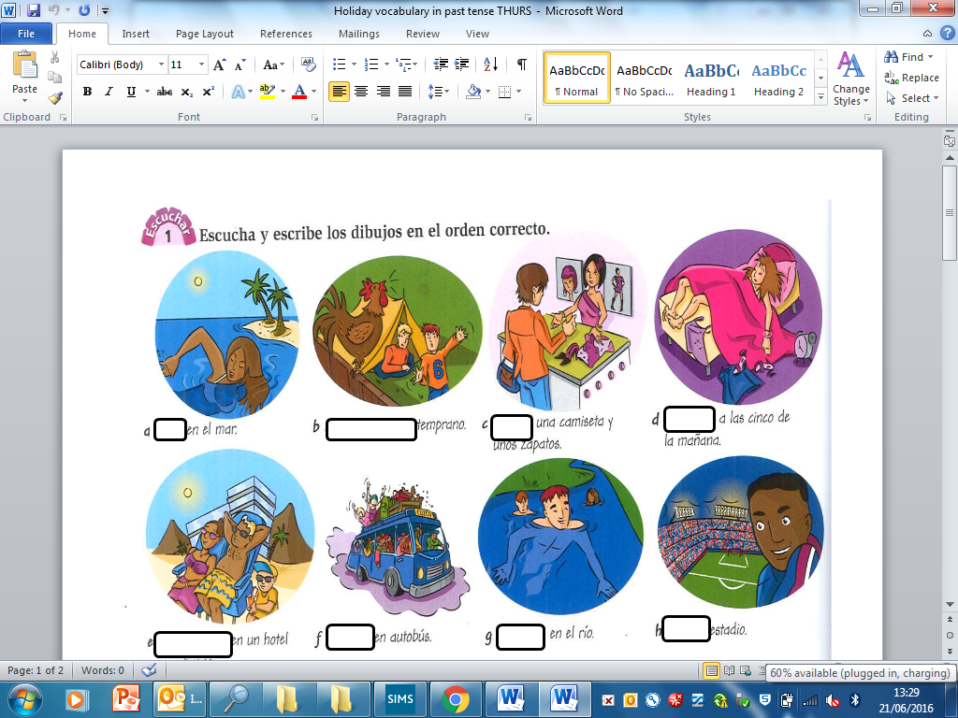

**Corrections, reactions to comments, new vocab etc……**

**b) Pon al español (Write in Spanish in your books)**

1. Last year I went to Spain. I visited a museum, a castle, a famous cathedral. Moreover, I went to the beach every day. What I liked the most was the climate as it was hot every day.

2. Three days ago we went to Madrid to visit the monuments. What I didn’t like was that it was full of tourists

3. During my holidays in Spain I went to bars and nightclubs. What I liked the most was the music.

4. During my first week of holidays I went for a bike ride in the centre of Barcelona. I had a great time! What I liked the most was the bar.



1. **Completa la hoja (complete the activities on this page)**
2. **Empareja (Match-up)**

|  |  |  |
| --- | --- | --- |
| 1. Cogí el avión |  | 1. I bought souvenirs |
| 1. Tomando el sol | 1. I took the plane |
| 1. Compré muchos recuerdos | 1. Sunbathing |
| 1. Fui a bares | 1. What I liked the most |
| 1. Lo que me gustó mas | 1. I went to bars |
| 1. Me desperté temprano | 1. I went horse-riding |
| 1. Pasé mucho tiempo en la playa | 1. I woke up early |
| 1. Monté a caballo | 1. I spent a lot of time on the beach |
| 1. Anteayer por la tarde | 1. And ancient palace |
| 1. Una palacio antiguo | 1. The day before yesterday in the evening |
| 1. Fui a ver | 1. It was picturesque |
| 1. Para comprar recuerdos | 1. They were beautiful |
| 1. Era pintoresco | 1. To buy souvenirs |
| 1. Eran hermosas | 1. I went to see |
| 1. Saqué muchísimas fotos | I took a lot of photos |

**c) Completa con el verbo apropiado (choose the appropriate verb each time)**

1. \_\_\_\_\_\_\_\_ platos locales muy ricos; 2. \_\_\_\_\_\_\_\_ mucho recuerdos; 3. \_\_\_\_\_ a bares; 4. \_\_\_\_\_\_\_\_\_ mucho tiempo en la playa tomando el sol; 5. Anteayer por la tarde \_\_\_\_\_\_\_ con mis amigos; 6. Me \_\_\_\_\_\_\_\_\_\_ temprano; 7. \_\_\_\_\_\_\_\_\_ muchísimas fotos; 8. \_\_\_\_\_\_\_\_\_ al futbol con mis amigos; 9. \_\_\_\_\_\_\_\_\_\_ el museo del Prado; 10. \_\_\_\_\_\_\_\_\_ a caballo; 11. \_\_\_\_\_\_\_\_\_ en taxi al aeropuerto; 12. \_\_\_\_\_\_\_\_ (=there were) muchas tiendas; 13. \_\_\_\_\_\_\_\_ buen tiempo; 14. Los monumentos \_\_\_\_\_\_ (=were) muy antiguos; 15. \_\_\_\_\_\_\_ en el mar; 16. \_\_\_\_\_\_\_\_\_\_el sol; 17. \_\_\_\_\_\_\_\_\_ una copa de vino en una bodega en la calle;

18. Lo que me \_\_\_\_\_\_\_ mas fue el clima; 19. \_\_\_\_\_\_\_ una vuelta en bici.

gustó/ comí/ bebí/ hizo/ jugué/ saqué/ fui/ pasé/ compré/ salí/ levanté/ monté/ viajé/ había/ eran/ tomé/ nadé/ di/ visité.

**3) El futuro – completa la tabla y el crucigrama (the future – complete the grid and crossword)**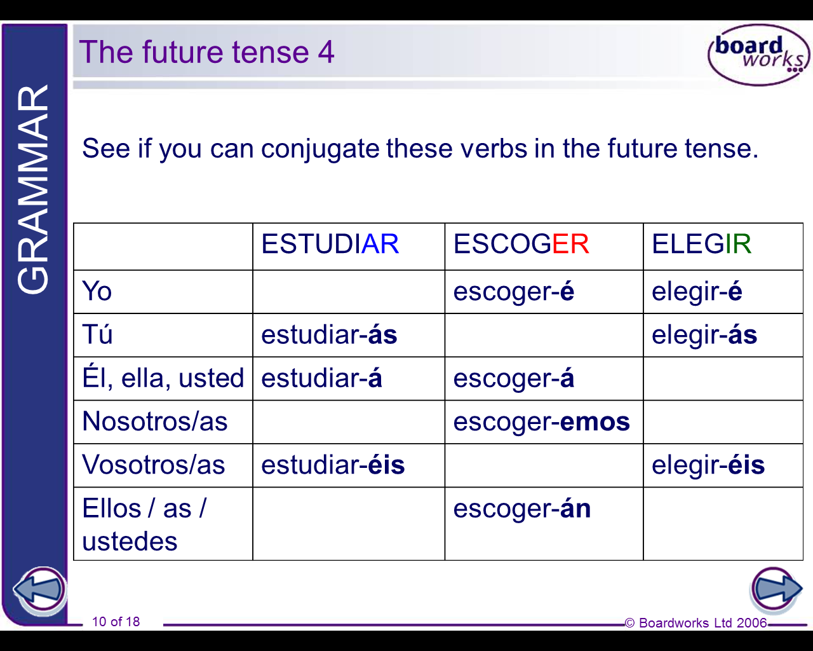

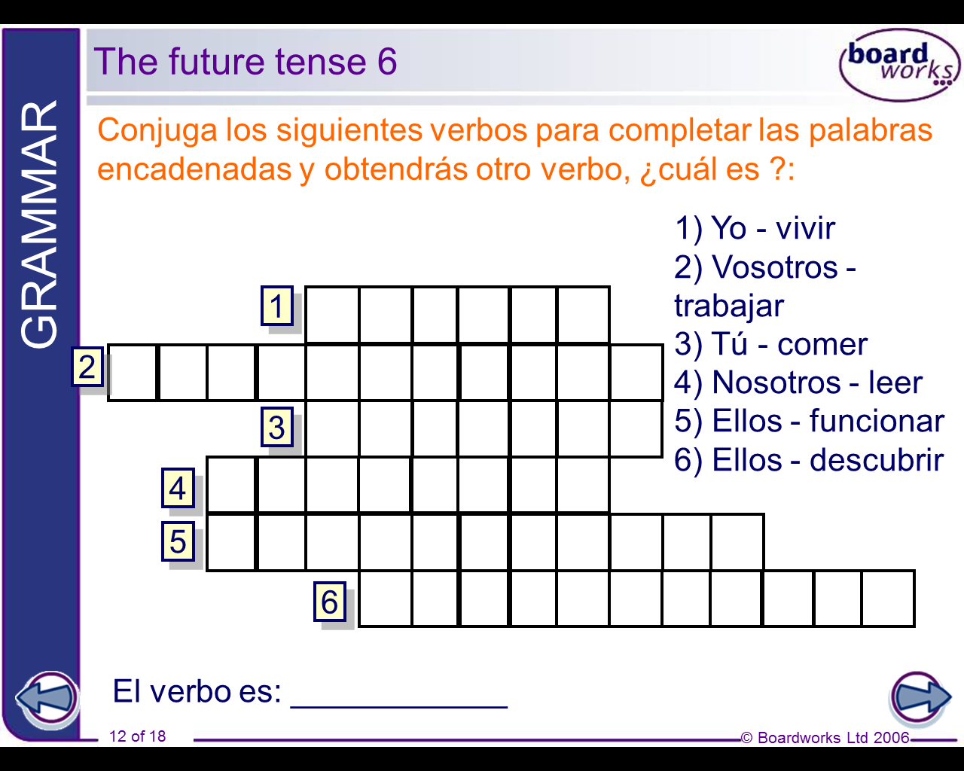

**Corrections, reactions to comments, new vocab etc……**

**Parte 5: Proyectos**

1. **Homework Project One**

|  |  |
| --- | --- |
| **Objective** | **To organise a trip to Seville for a family of four.** |
| **Outcomes** | * **To produce a document/travel pack that a family can take with them on a trip** * **To work out the cost of travel and access to tourist sites according to a budget** * **To suggest different places that they might want to visit and why according to their likes and dislikes** * **To produce an itinerary of places to visit** * **To find and present 3 appropriate hotels** |
| **Week 1**  **Homework**  **Due Date**  **\_\_/\_\_** | Read the following scenario:  ***“A family of four want to go to Seville during May half term (1st June – 9th June) for 3 days. The dad is 50 years of age and keen on football. The mum is 45 and enjoys dancing. The children, a boy and girl, are 12 and 10 years old respectively. The boy likes horse riding and the girl is sporty. They have a budget of £1000 and live in London.”***  Using the following airline websites, students need to work out which airline would be cheapest for the dates. Remember, however, that some airlines are better than others! Create an A4 sheet that breaks down the costs of the travel including the total price, how much it is per person and the departure and arrival times. Remember they have to leave from a London airport.  [www.easyjet.com](http://www.easyjet.com)  [www.ryanair.com](http://www.ryanair.com)  [www.iberia.com](http://www.iberia.com) |
| **Week 2 Homework**  **Due Date**  **\_\_/\_\_** | To research tourist places of interest in Seville that would fill 3 days in the city. Remember that the members of the family have likes and dislikes. Produce half an A4 page for each member of the family of places that might interest them. Students may want to use the lonely planet website as a starting point. Remember it has to be colourful and eye catching as it has to sell this holiday to the family.  <http://www.lonelyplanet.com/spain/seville/things-to-do> |
| **Week 3 Homework**  **Due Date**  **\_\_/\_\_** | Based on the cost of the transport, you need to find 3 potential places to stay in Seville. Perhaps a 3 star, 4 star and 5 star hotel as well as a youth hostel.  This website might be quite useful for finding the exact requirements of your hotel using the criteria on the left hand side.  <http://www.hotels.com/de447112/hotels-seville-spain/>  The different hotel options need to be presented including where they are, the costs of the hotels, pictures of the hotels and the facilities available. |
| **Week 4 Homework**  **Due Date**  **\_\_/\_\_** | Create an itinerary for the trip. Based on your travel, potential tourist visits and the hotel, create an itinerary for the 3 days in Seville from the moment they arrive to the moment they leave. Remember they will also need time to relax, sleep, eat, drink and perhaps do some shopping. This should be presented on one sheet of A4. |

1. **Homework Project Two**



|  |  |
| --- | --- |
| **Objective** | **To create a guide to a number of different Spanish festivals in Spain.** |
| **Outcomes** | **Students will work collaboratively and investigate 4 different festivals in Spain over the coming term. Each group will produce a booklet containing information about the festivals that could be used by a tourist or a Spanish student interested in the cultural event.** |
| Homework 1-4 | ***My group will be focusing on:***  **Week 1 Week 2 Week 3 Week 4**   1. La Tomatina 2. La Semana Santa 3. Les Falles 4. La noche vieja 5. El dia de los santos 6. Los Sanfermines   ***This week my responsibility is:***   1. History of the Festival 2. Description of the Fesitval 3. Picture Collage of the Festival   with descriptions  **Students A and B** are to create a summarised fact sheet of the festivals under discussion using a number of techniques such as bullet points, key word explanations, information boxes, glossaries etc.  **Student C** should create an A4 collage of pictures from the even using one powerpoint slide and photos from the internet. This should then be printed off in colour if possible.  Each homework, students will bring their homework to lesson and teachers should collect each group’s homework in a plastic wallet. At the end of the term this will be bound together to form their booklet. Booklets can then be passed around the class and used in an activity. |

**Corrections, reactions to comments, new vocab etc……**

**Homework tracker**

**i) vocab tests**

|  |  |  |  |  |  |  |  |
| --- | --- | --- | --- | --- | --- | --- | --- |
| **10** |  |  |  |  |  |  |  |
| **9** |  |  |  |  |  |  |  |
| **8** |  |  |  |  |  |  |  |
| **7** |  |  |  |  |  |  |  |
| **6** |  |  |  |  |  |  |  |
| **5** |  |  |  |  |  |  |  |
| **4** |  |  |  |  |  |  |  |
| **3** |  |  |  |  |  |  |  |
| **2** |  |  |  |  |  |  |  |
| **1** |  |  |  |  |  |  |  |
| **0** |  |  |  |  |  |  |  |
|  | **test 1** | **test 2** | **test 3** | **test 4** | **test 5** | **test 6** | **test 7** |
| *topic:* |  |  |  |  |  |  |  |

**ii) other tasks**

|  |  |  |  |  |  |  |  |
| --- | --- | --- | --- | --- | --- | --- | --- |
| **very good** |  |  |  |  |  |  |  |
| **good** |  |  |  |  |  |  |  |
| **satisfactory** |  |  |  |  |  |  |  |
| **unsatisfactory** |  |  |  |  |  |  |  |
| **not done on time** |  |  |  |  |  |  |  |
|  | **task 1** | **task 2** | **task 3** | **task 4** | **task 5** | **task 6** | **task 7** |
| *page no.* |  |  |  |  |  |  |  |

|  |  |  |  |  |  |  |  |
| --- | --- | --- | --- | --- | --- | --- | --- |
| **very good** |  |  |  |  |  |  |  |
| **good** |  |  |  |  |  |  |  |
| **satisfactory** |  |  |  |  |  |  |  |
| **unsatisfactory** |  |  |  |  |  |  |  |
| **not done on time** |  |  |  |  |  |  |  |
|  | **task 8** | **task 9** | **task 10** | **task 11** | **task 12** | **task 13** | **task 14** |
| *page no.* |  |  |  |  |  |  |  |